Contents
Struts 2 Architecture 2
Struts 1.x Vs Struts 2.x 6
Download Struts 2.0 8
Struts 2 Hello World - Developing Hello World Application 12
Writing JSP, Java and Configuration for Hello World Application 17
Struts Configuration file - struts.xml 23
Struts 2 Login Application 31
Struts 2 Validation Example 38
Validations using Struts 2 Annotations 40
Login/Logout With Session 48
Struts 2 MySQL 54
Rich Editor Example 61
Validate TextArea 64
Struts 2 Tags 69
Control Tags-If / Else If / Else 71
Append Tag (Control Tags) Example 73
Generator Tag (Control Tags) Example 75
Generator Tag (Control Tags) Using Count Attributes 77
Generator Tag (Control Tags) Using an Iterator with Id Attributes 79
Iterator Tag (Control Tags) Example 81
Merge Tag (Control Tags) Example 83
Subset Tag (Control Tags) Example 85
Subset Tag (Control Tags) Example Using Count 87
Subset Tag (Control Tags) Example Using Start 89
Action Tag (Data Tag) Example 91
Bean Tag (Data Tag) Example 92
Date Tag (Data Tag) Example 94
Include Tag (Data Tag) Example 97
Param Tag (Data Tag) Example 100
Set Tag (Data Tag) Example 102
Text Tag (Data Tag) Example 103
Text Tag (Data Tag) Example 105
Furthur references 107

Struts 2 Architecture
Down load struts-2: http://struts.apache.org/download.cgi
Down load tomcat 5.5: http://tomcat.apache.org/download-55.cgi

Struts and webwork has joined together to develop the Struts 2 Framework. Struts 2 Framework is very extensible and elegant for the development of enterprise web application of any size. In this section we are going to explain you the architecture of Struts 2 Framework.
Request Lifecycle in Struts 2 applications
- User Sends request: User sends a request to the server
for some resource.
- FilterDispatcher determines the appropriate action: The FilterDispatcher looks at the request and then determines the appropriate Action.
- Interceptors are applied: Interceptors configured for applying the common functionalities such as workflow, validation, file upload etc. are automatically applied to the request.
- Execution of Action: Then the action method is executed to perform the database

related operations like storing or retrieving data from the database.
- Output rendering: Then the Result renders the output.
- Return of Request: Then the request returns through the interceptors in the reverse order. The returning request allows us to perform the clean-up or additional processing.
- Display the result to user: Finally the control is returned to the servlet container, which sends the output to the user browser.
Image: Struts 2 high level overview of request processing:
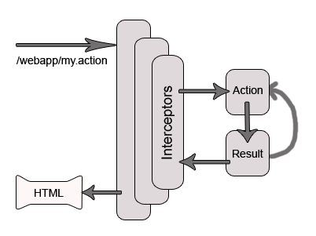
Struts 2 Architecture
Struts 2 is a very elegant and flexible front controller framework based on many standard technologies like Java Filters, Java Beans, ResourceBundles, XML etc.
For the Model, the framework can use any data access technologies like JDBC, EJB, Hibernate etc and for the View, the framework can be integrated with JSP

, JTL, JSF, Jakarta Velocity Engine, Templates, PDF, XSLT etc.
Exception Handling:
The Struts 2 Framework allows us to define exception handlers and inceptors.
- Exception Handlers:
Exception handlers allows us to define the exception handling procedure on global and local basis. Framework catches the exception and then displays the page of our choice with appropriate message and exception details.
- Interceptors:
The Interceptors are used to specify the "request-processing lifecycle" for an action. Interceptors are configured to apply the common functionalities like workflow, validation etc.. to the request.
Struts 2 Architecture
The following diagram depicts the architecture of Struts 2 Framework and also shows the the initial request goes to the servlet container such as tomcat, which is then passed through standard filer chain.
Image: Struts 2 Architecture
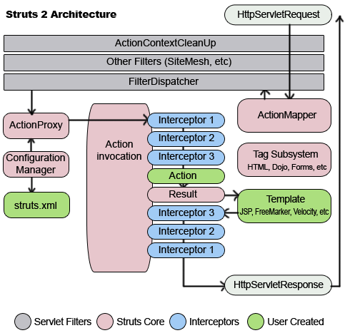
The filter chain includes:
- Action ContextCleanUp filter:
The ActionContextCleanUp filter is optional and it is useful when integration has to be done with other technologies like SiteMash Plugin.
- FilterDispatcher:
Next the FilterDispatch is called, which in turn uses the ActionMapper to determine whether to invoke an Action or not. If the action is required to be invoked, the FilterDispatcher delegates the control to the ActionProxy.
- ActionProxy:
The ActionProxy takes help from Configuration Files manager, which is initialized from the struts.xml. Then the ActionProxy creates an ActionInvocation, which implements the command pattern. The ActionInvocation process invokes the Interceptors (if configured) and then invokes the action. The the ActionInvocation looks for proper result. Then the result is executed, which involves the rendering of JSP or templates.
Then the Interceptors are executed again in reverse order. Finally the response returns through the filters configured in web.xml file. If the ActionContextCleanUp filter is configured, the FilterDispatcher does not clean the ThreadLocal ActionContext. If the ActionContextCleanUp filter is not present then the FilterDispatcher will cleanup all the ThreadLocals present.
In this section we have learnt about the Architecture of Struts 2 Framework.
The new version Struts 2.0 is a combination of the Sturts action framework and Webwork. According to the Struts 2.0.1 release announcement, some key features are:
- Simplified Design - Programming the abstract classes instead of interfaces is one of design problem of struts1 framework that has been resolved in the struts 2 framework. Most of the Struts 2 classes are based on interfaces and most of its core interfaces are HTTP independent. Struts 2 Action classes are framework independent and are simplified to look as simple POJOs. Framework components are tried to keep loosely coupled.
- Simplified Actions - Actions are simple POJOs. Any java class with execute() method can be used as an Action class. Even we don't need to implement interfaces always. Inversion of Control is introduced while developing the action classes. This make the actions to be neutral to the underlying framework .
- No more ActionForms - ActionForms feature is no more known to the struts2 framework. Simple JavaBean flavored actions are used to put properties directly. No need to use all String properties.
- Simplified testability - Struts 2 Actions are HTTP independent and framework neutral. This enables to test struts applications very easily without resorting to mock objects.
- Intelligent Defaults - Most configuration elements have a default value which can be set according to the need. Even there are xml-based default configuration files that can be overridden according to the need.
- Improved results - Unlike ActionForwards, Struts 2 Results provide flexibility to create multiple type of outputs and in actual it helps to prepare the response.
- Better Tag features - Struts 2 tags enables to add style sheet-driven markup capabilities, so that we can create consistent pages with less code. Struts 2 tags are more capable and result oriented. Struts 2 tag markup can be altered by changing an underlying stylesheet. Individual tag markup can be changed by editing a FreeMarker template. Both JSP and FreeMarker tags are fully supported.
- Annotations introduced : Applications in struts 2 can use Java 5 annotations as an alternative to XML and Java properties configuration. Annotations minimize the use of xml.
- Stateful Checkboxes - Struts 2 checkboxes do not require special handling for false values.
- QuickStart - Many changes can be made on the fly without restarting a web container.
- customizing controller - Struts 1 lets to customize the request processor per module, Struts 2 lets to customize the request handling per action, if desired.
- Easy Spring integration - Struts 2 Actions are Spring-aware. Just need to add Spring beans!
- Easy plugins - Struts 2 extensions can be added by dropping in a JAR. No manual configuration is required!
- AJAX support - The AJAX theme gives interactive applications a significant boost.
The framework provides a set of tags to help you ajaxify your applications, even on Dojo. The AJAX features include:
  - AJAX Client Side Validation
  - Remote form submission support (works with the submit tag as well)
  - An advanced div template that provides dynamic reloading of partial HTML
  - An advanced template that provides the ability to load and evaluate JavaScript remotely
  - An AJAX-only tabbed Panel implementation
  - A rich pub-sub event model
  - Interactive auto complete tag
Struts 1.x Vs Struts 2.x
Struts logic tags are conditional tags that replaces scriptlets in the jsp files.

Struts 1.x Vs Struts 2.x
In the following section, we are going to compare the various features between the two frameworks. Struts 2.x is very simple as compared to struts 1.x, few of its excelent features are:
1. Servlet Dependency:
Actions in Struts1 have dependencies on the servlet API since the HttpServletRequest and HttpServletResponse objects are passed to the execute method when an Action is invoked but in case of Struts 2, Actions are not container dependent because they are made simple POJOs. In struts 2, the servlet contexts are represented as simple Maps which allows actions to be tested in isolation. Struts 2 Actions can access the original request and response, if required. However, other architectural elements reduce or eliminate the need to access the HttpServetRequest or HttpServletResponse directly.
2. Action classes
Programming the abstract classes instead of interfaces is one of design issues of struts1 framework that has been resolved in the struts 2 framework.
Struts1 Action classes needs to extend framework dependent abstract base class. But in case of Struts 2 Action class may or may not implement interfaces to enable optional and custom services. In case of Struts 2 , Actions are not container dependent because they are made simple POJOs. Struts 2 provides a base ActionSupport class to implement commonly used interfaces. Albeit, the Action interface is not required. Any POJO object with an execute signature can be used as an Struts 2 Action object.
3. Validation
Struts1 and Struts 2 both supports the manual validation via a validate method.
Struts1 uses validate method on the ActionForm, or validates through an extension to the Commons Validator. However, Struts 2 supports manual validation via the validate method and the XWork Validation framework. The Xwork Validation Framework supports chaining validation into sub-properties using the validations defined for the properties class type and the validation context.
4. Threading Model
In Struts1, Action resources must be thread-safe or synchronized. So Actions are singletons and thread-safe, there should only be one instance of a class to handle all requests for that Action. The singleton strategy places restrictions on what can be done with Struts1 Actions and requires extra care to develop. However in case of Struts 2, Action objects are instantiated for each request, so there are no thread-safety issues. (In practice, servlet containers generate many throw-away objects per request, and one more object does not impose a performance penalty or impact garbage collection)
5. Testability
Testing Struts1 applications are a bit complex. A major hurdle to test Struts1 Actions is that the execute method because it exposes the Servlet API. A third-party extension, Struts TestCase, offers a set of mock object for Struts1. But the Struts 2 Actions can be tested by instantiating the Action, setting properties and invoking methods. Dependency Injection support also makes testing simpler. Actions in struts2 are simple POJOs and are framework independent, hence testability is quite easy in struts2.
6. Harvesting Input
Struts1 uses an ActionForm object to capture input. And all ActionForms needs to extend a framework dependent base class. JavaBeans cannot be used as ActionForms, so the developers have to create redundant classes to capture input.
However Struts 2 uses Action properties (as input properties independent of underlying framework) that eliminates the need for a second input object, hence reduces redundancy. Additionally in struts2, Action properties can be accessed from the web page via the taglibs. Struts 2 also supports the ActionForm pattern, as well as POJO form objects and POJO Actions. Even rich object types, including business or domain objects, can be used as input/output objects.
7. Expression Language
Struts1 integrates with JSTL, so it uses the JSTL-EL. The struts1 EL has basic object graph traversal, but relatively weak collection and indexed property support. Struts 2 can also use JSTL, however it supports a more powerful and flexible expression language called "Object Graph Notation Language" (OGNL).
8. Binding values into views
In the view section, Struts1 uses the standard JSP mechanism to bind objects (processed from the model section) into the page context to access. However Struts 2 uses a "ValueStack" technology so that the taglibs can access values without coupling your view to the object type it is rendering. The ValueStack strategy allows the reuse of views across a range of types which may have the same property name but different property types.
9. Type Conversion
Usually, Struts1 ActionForm properties are all Strings. Struts1 uses Commons-Beanutils for type conversion. These type converters are per-class and not configurable per instance. However Struts 2 uses OGNL for type conversion. The framework includes converters for basic and common object types and primitives.
10. Control Of Action Execution
Struts1 supports separate Request Processor (lifecycles) for each module, but all the Actions in a module must share the same lifecycle. However Struts 2 supports creating different lifecycles on a per Action basis via Interceptor Stacks. Custom stacks can be created and used with different Actions as needed.

Download Struts 2.0
In this section we will download and install the Struts 2.0 on the latest version of Tomcat container. We will first download tomcat and configure it as our development server. Then we will download Struts 2.0 and install the struts-blank application on the tomcat server to check the examples that come with the struts-blank application.
Downloading Struts 2.0
Visit the Struts download site http://struts.apache.org/download.cgi and download the Struts 2.0 for this tutorial.
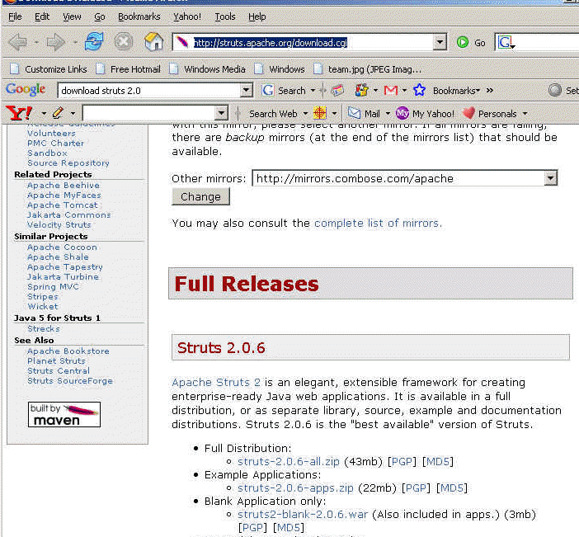
We have downloaded the Struts 2.0.6 (struts-2.0.6-all.zip) for this tutorial.
Download the Tomcat
Download the latest version of tomcat from http://tomcat.apache.org/download-55.cgi. We have downloaded apache-tomcat-5.5.20.zip for this tutorial.
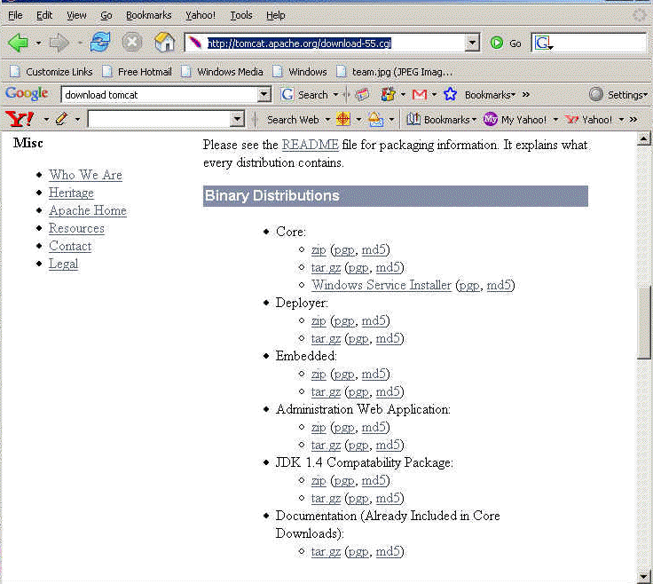
I am assuming that latest version of Java is installed on your system. Extract downloaded file and run the C:\apache-tomcat-5.5.20\bin\startup.bat to start the tomcat. Type http://localhost:8080/ in your browser, it should show the welcome page in the browser window as shown below.
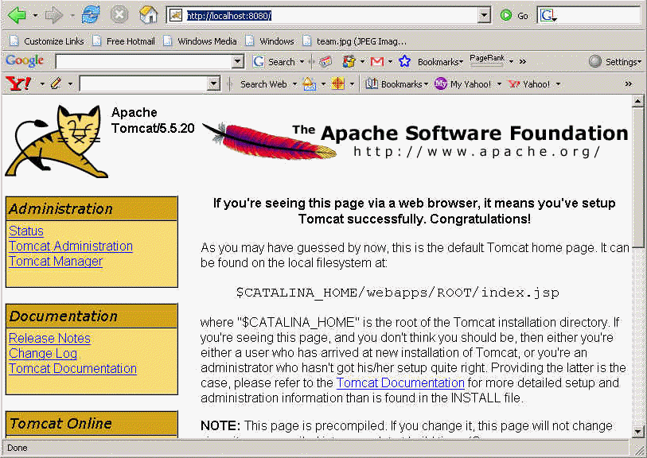
Congratulations you have now successfully installed latest version of tomcat for learning Struts 2.0. Now we will install the struts-blank application on the tomcat container and test the application.
Extracting Struts 2.0 distribution and installing on tomcat
Extract the downloaded struts distribution struts-2.0.6-all.zip into your favorite directory. To install the struts blank application copy "struts2-blank-2.0.6" from "<extracted directory>\struts-2.0.6-all\struts-2.0.6\apps" into the webapps directory of tomcat. Tomcat will automatically deploy the application.
Feb 25, 2007 11:42:23 PM org.apache.coyote.http11.Http11BaseProtocol start
INFO: Starting Coyote HTTP/1.1 on http-8080
Feb 25, 2007 11:42:24 PM org.apache.jk.common.ChannelSocket init
INFO: JK: ajp13 listening on /0.0.0.0:8009
Feb 25, 2007 11:42:24 PM org.apache.jk.server.JkMain start
INFO: Jk running ID=0 time=0/141 config=null
Feb 25, 2007 11:42:24 PM org.apache.catalina.storeconfig.StoreLoader load
INFO: Find registry server-registry.xml at classpath resource
Feb 25, 2007 11:42:24 PM org.apache.catalina.startup.Catalina start
INFO: Server startup in 6672 ms
Feb 25, 2007 11:52:55 PM org.apache.catalina.startup.HostConfig deployWAR
INFO: Deploying web application archive struts2-blank-2.0.6.war
To test the struts-blank application type http://localhost:8080/struts2-blank-2.0.6 in the browser and the struts-blank application get displayed in your browser window.
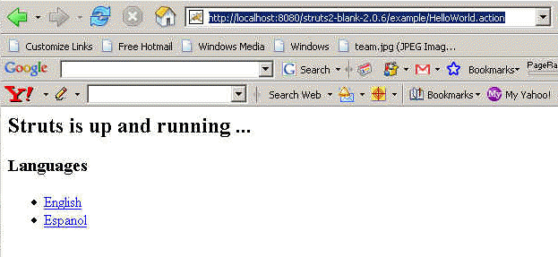
Click the English link and familiarize yourself with Struts Blank sample application.
Struts 2.0 distribution also contains the following sample applications that you can try:
- struts2-mailreader-2.0.6.war
- struts2-portlet-2.0.6.war
- struts2-showcase-2.0.6.war
You can simply copy these files to the webapps directory of your tomcat server. Tomcat will automatically deploy these applications and then you can test these applications.

Struts 2 Hello World - Developing Hello World Application
In this section we will develop Hello World application based on Struts 2 Framework. Our Struts 2 Hello World application is your first step towards developing applications based on Struts 2 Framework. We are here providing step by step guide for developing Hello World application in Struts 2 framework.
Tutorial covers basic steps like creating directory structure, developing build.xml file to build the application using ant build tool. Then we explained Java, JSP and configuration files that are required in this application.
Creating directory structure for the project
Step1: Extract struts 2 download and copy struts2-blank-2.0.6.war(If you are using latest version of struts 2 then version may be different for you) to your tomcats webapps directory. Rename struts2-blank-2.0.6.war to struts2tutorial and unzip it in the tomcats webapps directory. Now start the tomcat and type http://localhost:8080/struts2tutorial/ into your browser. You browser should show look like:
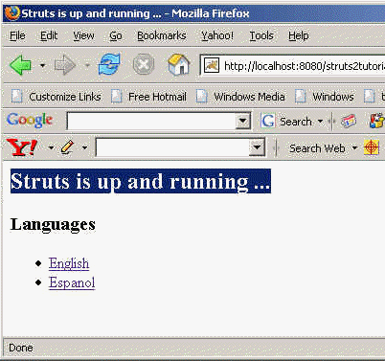
Congratulations you have successfully installed struts 2 blank application to start with.
Step 2: Now delete the content of struts2tutorial\WEB-INF\src and struts2tutorial\WEB-INF\classes directories, as we don't need these files that comes with struts 2 blank application.
Step 3: Create build.xml file in the struts2tutorial\WEB-INF\src and paste the following content in the build.xml file.
<project name="Struts 2 Tutorial" basedir="../" default="all">
<!-- Project settings -->
<property name="project.title" value="RoseIndia Struts 2 Tutorials"/>
<property name="project.jar.file" value="struts2tutorial.jar"/>

<path id="class.path">

<fileset dir="lib">

<include name="**/*.jar"/>

</fileset>

<fileset dir="libext">

<include name="**/*.jar"/>

</fileset>

</path>

<!-- Classpath for Project -->

<path id="compile.classpath">

<pathelement path ="lib/commons-beanutils.jar"/>

<pathelement path ="lib/commons-digester.jar"/>

<pathelement path ="lib/struts.jar"/>

<pathelement path ="libext/servlet-api.jar"/>

<pathelement path ="libext/catalina-ant.jar"/>

<pathelement path ="classes"/>

<pathelement path ="${classpath}"/>

</path>

<!-- Check timestamp on files -->

<target name="prepare">

<tstamp/>
<copy
file="src/struts.xml"
todir="src/classes"/>

</target>
<!-- Copy any resource or configuration files -->

<target name="resources">

<copy todir="src/classes" includeEmptyDirs="no">

<fileset dir="src/java">

<patternset>

<include name="**/*.conf"/>

<include name="**/*.properties"/>

<include name="**/*.xml"/>

</patternset>

</fileset>

</copy>

</target>

<!-- Normal build of application -->

<target name="compile" depends="prepare,resources">

<javac srcdir="src" destdir="src/classes"
debug="true" debuglevel="lines,vars,source">

<classpath refid="class.path"/>

</javac>

<jar

jarfile="lib/${project.jar.file}"

basedir="src/classes"/>

</target>
<!-- Remove classes directory for clean build -->

<target name="clean"

description="Prepare for clean build">

<delete dir="classes"/>

<mkdir dir="classes"/>

</target>

<!-- Build Javadoc documentation -->

<target name="javadoc"

description="Generate JavaDoc API docs">

<delete dir="./doc/api"/>

<mkdir dir="./doc/api"/>

<javadoc sourcepath="./src/java"

destdir="./doc/api"

classpath="${servlet.jar}:${jdbc20ext.jar}"

packagenames="*"

author="true"

private="true"

version="true"

windowtitle="${project.title} API Documentation"

doctitle="&lt;h1&gt;${project.title}
Documentation (Version ${project.version})&lt;/h1&gt;"

bottom="Copyright &#169; 2002">

<classpath refid="compile.classpath"/>

</javadoc>

</target>

<!-- Build entire project -->

<target name="project" depends="clean,prepare,compile"/>

<!-- Create binary distribution -->

<target name="dist"

description="Create binary distribution">

<mkdir

dir="${distpath.project}"/>

<jar
jarfile="${distpath.project}/${project.distname}.jar"

basedir="./classes"/>

<copy

file="${distpath.project}/${project.distname}.jar"

todir="${distpath.project}"/>

<war

basedir="../"

warfile="${distpath.project}/${project.distname}.war"

webxml="web.xml">

<exclude name="${distpath.project}/${project.distname}.war"/>

</war>

</target>

<!-- Build project and create distribution-->

<target name="all" depends="project"/>

</project>
Step 4: Create directory libext under the struts2tutorial\WEB-INF\ then you copy latest Servlets api jar (in our case servlet-api.jar) file over there. This library file will be used to compile Servlets in our application.
Step 5: Now create directories java and classes under struts2tutorial\WEB-INF\src. The directory struts2tutorial\WEB-INF\src\java will be used to put all the java sources file and directory struts2tutorial\WEB-INF\src\classes will be used by ant build utility to store compiled java files.
Now we have successfully created the directory structure and ant build file for our Struts 2 Hello World Application. In the next section we will create JSP, Java file and the configuration file and then test our Struts 2 Hello World application.

Writing JSP, Java and Configuration for Hello World Application
In this section we will write JSP, Java and required configuration files for our Struts 2 Hello World application. Now in struts 2 struts.xml is used to configure the applications.
Understanding the application
Our application is very simple application that displays Hello World message along with current date and time of the server. When user clicks on the "Run Struts 2 Hello World Application" link on the tutorial home page, a request is sent to the struts framework. Then struts framework sends the input to the action class (in our case Struts2HelloWorld.java). After action is fired the Result selects the resource "/pages/HelloWorld.jsp" to render the response.
In this example we have to develop three parts view, Action class and mapping (struts.xml) to couple action and page. By creating these three components we are separating the application in three parts View, Model and Controller.
Developing View:
This page is used to display the result on the browser. The HelloWorld.jsp is view part of our application. Create "HelloWorld.jsp" in the struts2tutorial\pages directory and add the following content:
<%@ taglib prefix="s" uri="/struts-tags" %>
<html>
<head>
<title>Struts 2 Hello World Application!</title>
</head>
<body>
<h2><s:property value="message" /></h2>
<p>Current date and time is: <b><s:property value="currentTime" /></b>
</body>
</html>
The line <%@ taglib prefix="s" uri="/struts-tags" %> declares data tag library of struts. The struts data tag is used to display the dynamic data. The tag <s:property value="message" /> and <s:property value="currentTime" /> calls the methods getMessage() and getCurrentTime() respectively of the Struts2HelloWorld action class and merges the values with response.
Developing Action (to interact with Model):
Now create Struts2HelloWorld.java and saves it to the "struts2tutorial\WEB-INF\src\java\net\roseindia" directory. This action class creates the message to be displayed on the screen. Here is the code of Struts2HelloWorld.java:
package net.roseindia;
import com.opensymphony.xwork2.ActionSupport;
import java.util.Date;
public class Struts2HelloWorld extends ActionSupport {
public static final String MESSAGE = "Struts 2 Hello World Tutorial!";
public String execute() throws Exception {
setMessage(MESSAGE);
return SUCCESS;
}
private String message;
public void setMessage(String message){
this.message = message;
}
public String getMessage() {
return message;
}
public String getCurrentTime(){
return new Date().toString();
}
}
Developing Controller Configuration File:
Struts 2 uses the struts.xml file for configuring the application. Create struts.xml file and save it in the "struts2tutorial\WEB-INF\src" directory with the following content.
<?xml version="1.0" encoding="UTF-8" ?>
<!DOCTYPE struts PUBLIC
"-//Apache Software Foundation//DTD Struts Configuration 2.0//EN"
"http://struts.apache.org/dtds/struts-2.0.dtd">
<struts>
<constant name="struts.enable.DynamicMethodInvocation" value="false" />
<constant name="struts.devMode" value="true" />
<package name="roseindia" namespace="/roseindia" extends="struts-default">
<action name="HelloWorld" class="net.roseindia.Struts2HelloWorld">
<result>/pages/HelloWorld.jsp</result>
</action>
<!-- Add actions here -->
</package>
<!-- Add packages here -->
</struts>
The struts.xml file should be present in the class path of the application, you can either include it in the jar and place in the lib directory of the application or place it in the classes directory of the web application. In our application we are using ant build tool which is including it in the jar file.
Building the application
I am assuming that you have already installed ant build tool on your machine. Since we are using the ant built tool, building application by using is very easy. To build the application open command prompt and go to "struts2tutorial\WEB-INF\src" directory of the web application and issue the "ant" command. The ant build tool will compile the java file and create jar file "struts2tutorial.jar" into the lib directory of your web application. Here is the output of ant build tool:
C:\apache-tomcat-6.0.10\apache-tomcat-6.0.10\webapps\struts2tutorial\WEB-INF\src
>ant
Buildfile: build.xml
clean:
[delete] Deleting directory C:\apache-tomcat-6.0.10\apache-tomcat-6.0.10\webapps\struts2tutorial\WEB-INF\classes
[mkdir] Created dir: C:\apache-tomcat-6.0.10\apache-tomcat-6.0.10\webapps\struts2tutorial\WEB-INF\classes
prepare:
resources:
compile:
[javac] Compiling 1 source file to C:\apache-tomcat-6.0.10\apache-tomcat-6.0.10\webapps\struts2tutorial\WEB-INF\src\classes
[jar] Building jar: C:\apache-tomcat-6.0.10\apache-tomcat-6.0.10\webapps\struts2tutorial\WEB-INF\lib\struts2tutorial.jar
project:
all:
BUILD SUCCESSFUL
Total time: 7 seconds
C:\apache-tomcat-6.0.10\apache-tomcat-6.0.10\webapps\struts2tutorial\WEB-INF\src
>
Testing Struts 2 Hello World Application
In the above section we have compiled our application and now finally we will test our application. To test the application start the tomcat server and type http://localhost:8080/struts2tutorial/ and then select "Run Struts 2 Hello World Application" from the list.
Here is the screen shot of our struts 2 tutorial home page:
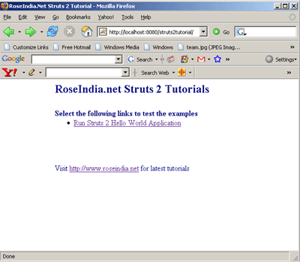
Select "Run Struts 2 Hello World Application" link. Our first application "Struts 2 Hello World" will look like the following:
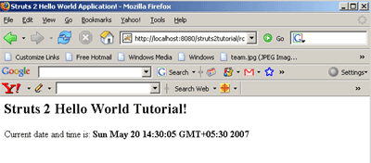
The application will display message "Struts 2 Hello World Tutorial!" along with current date and time of the server.
How application works?
Here is the brief description on how Struts 2 Hello World Application works:
Your browser sends a request to the web server for the URL http://localhost:8080/tutorial/HelloWorld.action.
- When you click on the "Run Struts 2 Hello World Application" link, the browser sends a request for the url http://localhost:8080/struts2tutorial/roseindia/HelloWorld.action. The container requests for the resource "HelloWorld.action". By default web.xml file of struts blank application is configured to route all the request for *.action through org.apache.struts2.dispatcher.FilterDispatcher. Here is the configuration from web.xml file:
<filter>
<filter-name>struts2</filter-name>
<filter-class>org.apache.struts2.dispatcher.FilterDispatcher</filter-class>
</filter>
<filter-mapping>
<filter-name>struts2</filter-name>
<url-pattern>/*</url-pattern>
</filter-mapping>
- Then the framework looks for the mapping for the action "HelloWorld" and then framework instantiates the appropriate class and calls the execute method. In this case action class is Struts2HelloWorld. Here is the configuration file from struts.xml which defines the action mapping:
<action name="HelloWorld" class="net.roseindia.Struts2HelloWorld">
<result>/pages/HelloWorld.jsp</result>
</action>
- Then the execute method sets the message and returns SUCCESS.
public String execute() throws Exception {
setMessage(MESSAGE);
return SUCCESS;
}
Then framework determines which page is to be loaded if SUCCESS is returned. In our case framework tells the container to load HelloWorld.jsp and render the output.
In the struts 2 framework Actions are used to process the form and user request. The execute method of the action returns SUCCESS, ERROR, or INPUT value. Then based on these values framework tells the container to load and render the appropriate result.
- Container process the HelloWorld.jsp and generates the output.
- Then the output in the HTML format is sent to the browser.
Download the application and source code:
You can download the application and source code of the tutorial and to save your time and efforts spent on configuring the application. Click here to download the code.
Our goal is to provide the working skeleton of the application based on ant tool. So you can download the application and then use ant tool to compile the java classes. Application is in the exploded directory structure and can be deployed as it is on tomcat server. If any of our visitor finds and problem please discuss it. We request you to share your experiences with us.

Struts Configuration file - struts.xml
In this section we will introduce you to the struts.xml file. This section explains you how best you can use the struts.xml file for you big projects.
The struts.xml File
The Struts 2 Framework uses a configuration file (struts.xml) to initialize its own resources. These resources include:
- Interceptors that can preprocess and postprocess a request
- Action classes that can call business logic and data access code
- Results that can prepare views using JavaServer Pages, Velocity and FreeMarker templates
At runtime, there is a single configuration for an application. Prior to runtime, the configuration is defined through one or more XML documents, including the default struts.xml document. There are several elements that can be configured, including packages, namespaces, includes, actions, results, interceptors, and exceptions.
The struts.xml file is the core configuration file for the framework and it should be present in the class path of your web application. Features of struts 2 configuration file:
- The struts.xml file allows to break big struts.xml file into small files and configuration files to be included as needed. Here is the example:
<struts>
.....
......
<include file="file1.xml"/>
<include file="file2.xml"/>
.....
.....
</struts>

- You can even place struts-plugin.xml file in the JAR, and it will be automatically plugged into the application. This helps the programmers to develop self-configured components.
- If you want to use the frameworks such as Freemaker and Velocity modules, then the templates can also be loaded from classpath. This enables the developer to package entire module just in single JAR file.
Structure of the struts.xml file
In the last section we developed and tested the Hello World application. Here is the sample struts.xml file from the last example.
<?xml version="1.0" encoding="UTF-8" ?>
<!DOCTYPE struts PUBLIC
"-//Apache Software Foundation//DTD Struts Configuration 2.0//EN"
"http://struts.apache.org/dtds/struts-2.0.dtd">
<struts>
<constant name="struts.enable.DynamicMethodInvocation" value="false" />
<constant name="struts.devMode" value="true" />
<package name="roseindia" namespace="/roseindia" extends="struts-default">
<action name="HelloWorld" class="net.roseindia.Struts2HelloWorld">
<result>/pages/HelloWorld.jsp</result>
</action>
<!-- Add actions here -->
</package>
<!-- Add packages here -->
</struts>
The struts.xml file must confirm to the Struts 2 Document Type Definition (DTD)
The DTD provides information about the structure and the elements that the struts.xml file should have.
Here is the Struts 2.0 DTD :
<!--
Struts configuration DTD.
Use the following DOCTYPE

<!DOCTYPE struts PUBLIC
"-//Apache Software Foundation//DTD Struts Configuration 2.0//EN"
"http://struts.apache.org/dtds/struts-2.0.dtd">
-->

<!ELEMENT struts (package|include|bean|constant)*>

<!ELEMENT package (result-types?, interceptors?,
default-interceptor-ref?, default-action-ref?, global-results?,
global-exception-mappings?, action*)>
<!ATTLIST package
name CDATA #REQUIRED
extends CDATA #IMPLIED
namespace CDATA #IMPLIED
abstract CDATA #IMPLIED
externalReferenceResolver NMTOKEN #IMPLIED
>

<!ELEMENT result-types (result-type+)>

<!ELEMENT result-type (param*)>
<!ATTLIST result-type
name CDATA #REQUIRED
class CDATA #REQUIRED
default (true|false) "false"
>

<!ELEMENT interceptors (interceptor|interceptor-stack)+>

<!ELEMENT interceptor (param*)>
<!ATTLIST interceptor
name CDATA #REQUIRED
class CDATA #REQUIRED
>

<!ELEMENT interceptor-stack (interceptor-ref+)>
<!ATTLIST interceptor-stack
name CDATA #REQUIRED
>

<!ELEMENT interceptor-ref (param*)>
<!ATTLIST interceptor-ref
name CDATA #REQUIRED
>

<!ELEMENT default-interceptor-ref (param*)>
<!ATTLIST default-interceptor-ref
name CDATA #REQUIRED
>

<!ELEMENT default-action-ref (param*)>
<!ATTLIST default-action-ref
name CDATA #REQUIRED
>

<!ELEMENT global-results (result+)>

<!ELEMENT global-exception-mappings (exception-mapping+)>

<!ELEMENT action (param|result|interceptor-ref|exception-mapping)*>
<!ATTLIST action
name CDATA #REQUIRED
class CDATA #IMPLIED
method CDATA #IMPLIED
converter CDATA #IMPLIED
>

<!ELEMENT param (#PCDATA)>
<!ATTLIST param
name CDATA #REQUIRED
>

<!ELEMENT result (#PCDATA|param)*>
<!ATTLIST result
name CDATA #IMPLIED
type CDATA #IMPLIED
>

<!ELEMENT exception-mapping (#PCDATA|param)*>
<!ATTLIST exception-mapping
name CDATA #IMPLIED
exception CDATA #REQUIRED
result CDATA #REQUIRED
>

<!ELEMENT include (#PCDATA)>
<!ATTLIST include
file CDATA #REQUIRED
>

<!ELEMENT bean (#PCDATA)>
<!ATTLIST bean
type CDATA #IMPLIED
name CDATA #IMPLIED
class CDATA #REQUIRED
scope CDATA #IMPLIED
static CDATA #IMPLIED
optional CDATA #IMPLIED
>

<!ELEMENT constant (#PCDATA)>
<!ATTLIST constant
name CDATA #REQUIRED
value CDATA #REQUIRED
>
It is possible to remove the “struts.xml” file from your application completely if the functionality of your application does not depends on it. There are few configurations that can be handled alternatively such as annotations, “web.xml” startup parameters, and alternate URL mapping schemes. Still, there are few configurations that always need the “struts.xml” file like the global results, exception handling, and the custom interceptor stacks.
Exploring struts.xml
The <struts> tag is the root tag for the struts.xml. It may contain the following tags : package, include, bean and constant.
1. The Package Tag :
Packages are a way to group actions, results, result types, interceptors, and interceptor-stacks into a logical configuration unit. Conceptually, packages are similar to objects in that they can be extended and have individual parts that can be overridden by "sub" packages.
The <package /> tag is used to group together configurations that share common attributes such as interceptor stacks or URL namespaces. It may also be useful to organizationally separate functions, which may be further separated into different configuration files.
The package element has one required attribute, name, which acts as the key for later reference to the package. The extends attribute is optional and allows one package to inherit the configuration of one or more previous packages - including all interceptor, interceptor-stack, and action configurations.
Note that the configuration file is processed sequentially down the document, so the package referenced by an "extends" should be defined above the package which extends it.
The optional abstract attribute creates a base package that can omit the action configuration.
Attribute | Required | Description
name | yes | key for other packages to reference
extends | no | inherits package behavior of the package it extends
namespace | no | provides a mapping from the URL to the package.
abstract | no | declares package to be abstract (no action configurations required in package)
1. name – unique name is given for a package.
2. extends – the name of a package that this package will extend; all configuration information (including action configurations) from the extended package will be available in the new package, under the new namespace.
3. namespace – the namespace provides a mapping from the URL to the package. i.e. for two different packages, with namespace attributes defined as “pack1” and “pack2”, the URLs would be something like “/webApp/pack1/my.action” and “/webApp/pack2/my.action”
4. abstract – if this attribute value is “true” the package is truly a configuration grouping and actions configured will not be accessible via the package name. It is important to make sure you are extending the correct parent package so that the necessary pre-configured features will be available to you.
2. The Include Tag:
The <include /> tag is used to modularize a Struts2 application that needs to include other configuration files. It contains only one attribute “file” that provides the name of the xml file to be included. This file has exactly the same structure as the “struts.xml” configuration file. For example, to break a configuration file of a finance application, you might choose to group together the invoices, admin, report configurations etc into separate files:
<struts>
<include file="invoices-config.xml" />
<include file="admin-config.xml" />
<include file="reports-config.xml" />
</struts>

While including files, order is important. The information from the included file will be available from the point that the include tag is placed in the file.
There are some files that are included implicitly. These are the “strutsdefault.xml” and the “struts-plugin.xml” files. Both contains default configurations for result types, interceptors, interceptor stacks, packages as well as configuration information for the web application execution environment (which can also configured in the “struts.properties” file). The difference is that “struts-default.xml” provides the core configuration for Struts2, where “struts-plugin.xml” provides configurations for a particular plug-in. Each plug-in JAR file should contain a “struts-plugin.xml” file, all of which are loaded during startup.
3. The Bean Tag
Most applications won't need to extend the Bean Configuration. The bean element requires the class attribute which specifies the Java class to be created or manipulated. A bean can either
- be created by the framework's container and injected into internal framework objects, or
- have values injected to its static methods
The first use, object injection, is generally accompanied by the type attribute, which tells the container that which interface this object implements.
The second use, value injection, is good for allowing objects not created by the container to receive framework constants. Objects using value inject must define the the static attribute.
Attribute | Required | Description
class | yes | the name of the bean class
type | no | the primary Java interface this class implements
name | no | the unique name of this bean; must be unique among other beans that specify the same type
scope | no | the scope of the bean; must be either default, singleton, request, session, thread
static | no | whether to inject static methods or not; shouldn't be true when the type is specified
optional | no | whether the bean is optional or not
Bean Example (struts.xml)

<struts>
<bean type="roseindia.net.ObjectFactory" name="factory" class="roseindia.net.MyObjectFactory" />
...
</struts>
4. The Constant Tag
There are two key roles for constants.
1. They are used to override settings like the maximum file upload size or whether the Struts framework should be in devMode(= development mode) or not.
2. They specify which Bean should be chosen, among multiple implementations of a given type.
Constants can be declared in multiple files. By default, constants are searched for in the following order, allowing for subsequent files to override by the previous ones:
- struts-default.xml
- struts-plugin.xml
- struts.xml
- struts.properties
- web.xml
The struts.properties file is provided for backward-compatiblity with WebWork. In the struts.properties file, each entry is treated as a constant. In the web.xml file, any FilterDispatcher initialization parameters are loaded as constants.
In the various XML variants, the constant element has two required attributes : name and value.
Attribute | Required | Description
name | yes | the name of the constant
value | yes | the value of the constant
Constant Example (struts.xml)

<struts>
<constant name="struts.devMode" value="true" />
...
</struts>

Constant Example (struts.properties)
struts.devMode = true

Struts 2 Login Application
Developing Struts 2 Login Application
In this section we are going to develop login application based on Struts 2 Framework. Our current login application does not validate the user against the database. Instead login name and password are validated against the hardcode values (User: Admin and Password: Admin) in the actions class.
Working of the application
- Login page is displayed to take the input.
- User enters user name and password and then clicks on the "Login" button.
- User validation is done in action class and if user enters Admin/Admin in the user name/password fields, then success pages is displayed. Otherwise the error message is displayed on the screen.
Steps to develope the application
Here are simple and easy steps to develop Login page in the using Struts 2 framework.
- Develop Login Form
The GUI of the application consists of login form (login.jsp) and success message page (loginsuccess.jsp).
The login.jsp is used to display the login page to the user. In our application it is saved in "webapps\struts2tutorial\pages\" folder. Here is the code of login.jsp file:
<%@ taglib prefix="s" uri="/struts-tags" %>
<html>
<head>
<title>Struts 2 Login Application!</title>
<link href="<s:url value="/css/main.css"/>" rel="stylesheet" type="text/css"/>
</head>
<body>
<s:form action="doLogin" method="POST">
<tr>
<td colspan="2">
Login
</td>
</tr>
<tr>
<td colspan="2">
<s:actionerror />
<s:fielderror />
</td>
</tr>
<s:textfield name="username" label="Login name"/>
<s:password name="password" label="Password"/>
<s:submit value="Login" align="center"/>
</s:form>
</body>
</html>
- The code :
<s:actionerror />
<s:fielderror />
displays action errors and field validation errors.
- The code <s:form action="doLogin" method="POST"> generates the html form for the application.
The code :
<s:textfield name="username" label="Login name"/>
<s:password name="password" label="Password"/>
generates Login Name and Password fields.
- The submit button is generated through <s:submit value="Login" align="center"/> code.
When application is executed it generates the following html code:
<html>
<head>
<title>Struts 2 Login Application!</title>

<link href="/struts2tutorial/css/main.css" rel="stylesheet"
type="text/css"/>

</head>
<body>
<form id="doLogin" name="doLogin" onsubmit="return true;"
action="/struts2tutorial/roseindia/doLogin.action" method="POST">
<table class="wwFormTable">

<tr>
<td colspan="2">
Login
</td>

</tr>

<tr>
<td class="tdLabel"><label for="doLogin_username" class="label">
Login name:</label>
</td>
<td><input type="text" name="username" value="" id="doLogin_username"/>
</td>
</tr>

<tr>
<td class="tdLabel"><label for="doLogin_password" class="label">
Password:</label></td>
<td><input type="password" name="password" id="doLogin_password"/>
</td>
</tr>

<tr>
<td colspan="2"><div align="center"><input type="submit"
id="doLogin_0" value="Login"/>
</div></td>
</tr>
</table></form>
</body>

</html>
- On viewing the above generated html code you will find that Struts 2 automatically generates form, html table, label for the html elements. This is the another great feature of Struts as compared to Struts 1.x.
The loginsuccess.jsp page displays the Login Success message when user is authenticated successfully. Here is the code of loginsuccess.jsp file:
<html>
<head>
<title>Login Success</title>
</head>
<body>
<p align="center"><font color="#000080" size="5">Login Successful</font></p>
</body>
</html>

- Developing Action Class
Now let's develop the action class to handle the login request. In Struts 2 it is not necessary to implement the Action interface, any POJO object with execute signature can be used in Struts 2. The Struts 2 framework provides a base ActionSupport class to implement commonly used interfaces. In our action class (Login.java

) we have implemented ActionSupport interface. Our "Login.java" is saved in the "webapps\struts2tutorial\WEB-INF\src\java\net\roseindia" directoy. Here is the code of Login.java action class:
package net.roseindia;
import com.opensymphony.xwork2.ActionSupport;
import java.util.Date;
/**
* <p> Validate a user login. </p>
*/
public class Login extends ActionSupport {
public String execute() throws Exception {
System.out.println("Validating login");
if(!getUsername().equals("Admin") || !getPassword().equals("Admin")){
addActionError("Invalid user name or password! Please try again!");
return ERROR;
}else{
return SUCCESS;
}
}
// ---- Username property ----
/**
* <p>Field to store User username.</p>
* <p/>
*/
private String username = null;
/**
* <p>Provide User username.</p>
*
* @return Returns the User username.
*/
public String getUsername() {
return username;
}
/**
* <p>Store new User username</p>
*
* @param value The username to set.
*/
public void setUsername(String value) {
username = value;
}
// ---- Username property ----
/**
* <p>Field to store User password.</p>
* <p/>
*/
private String password = null;
/**
* <p>Provide User password.</p>
*
* @return Returns the User password.
*/
public String getPassword() {
return password;
}
/**
* <p>Store new User password</p>
*
* @param value The password to set.
*/
public void setPassword(String value) {
password = value;
}
}

- Configuring action mapping (in struts.xml)
Now we will create action mapping in the struts.xml file. Here is the code to be added in the struts.xml:
<action name="showLogin">
<result>/pages/login.jsp</result>
</action>
<action name="doLogin" class="net.roseindia.Login">
<result name="input">/pages/login.jsp</result>
<result name="error">/pages/login.jsp</result>
<result>/pages/loginsuccess.jsp</result>
</action>
- In the above mapping the action "showLogin" is used to display the login page and "doLogin" validates the user using action class (Login.java).
- CSS file (main.css)
This css file is used to enhance the presentation of the login form. The main.css is saved into "\webapps\struts2tutorial\css" directory.
Here is the code of main.css:
@CHARSET "UTF-8";
body {
font: 12px verdana, arial, helvetica, sans-serif;
background-color:#FFFFFF;
}
table.wwFormTable {
font: 12px verdana, arial, helvetica, sans-serif;
border-width: 1px;
border-color: #030;
border-style: solid;
color: #242;
background-color: #ada;
width: 30%;
margin-left:35%;
margin-right:35%;
margin-top:15%;
}
table.wwFormTable th {
}
table.wwFormTable tr td {
background-color: #dfd;
margin: 5px;
padding: 5px;
}
.tdLabel {
/*
border-width: 1px;
border-color: #afa;
border-style: solid;
*/
font-weight: bold;
align: top;
}
.label {
}
.errorMessage {
color: red;
font-size: 0.8em;
}
#headerDiv {
border-style: solid;
border-width: 1px 1px 0px;
border-color: black;
padding: 5px;
background-color: #7a7;
/* height: 22px; */
height: 1.8em;
/* margin-bottom: 12px; */
}
#buttonBar {
border-width: 0px 1px 1px;
border-style: solid;
border-color: black;
color: white;
margin-bottom: 12px;
background-color: #7a7;
height: 1.6em;
padding: 5px;
}
#appName {
color: white;
font-size: 1.8em;
}
#pageTitle {
font-size: 1.4em;
color: #dfd;
clear: none;
}
#appName, #pageTitle {
float: right;
}
#menuContainer {
float: left;
}
#brandingContainer {
float: right:
text-align: right;
}
In the next section we will learn how to add validation to the login application.

Struts 2 Validation Example
Validation Login application
In this section we will write the code to validate the login application. After completing this section you will be able to write validations for your Struts 2 projects. The concepts defined in this section are so illustrative that a learner quickly develops his/her skills in Struts 2 framework.
Struts 2 is very elegant framework that provides a lot of functionality to develop web based applications quickly. Here you will learn to write the form validation code in Struts 2 very easily. We will add the form validation code in our login application.
For validation the login application java script can be added to the jsp page or in action class, but Struts 2 provides another very easy method to validate your fields automatically. You can even use the same configuration file to generate client side script ( in next section we will see how to generate client side validation code).
The Struts 2 validation framework uses xml based configuration file. The file name should be <Your action class> -validation.xml. In our case our action class name is Login.java, so our validation configuration file will be Login-validation.xml. The Login-validation.xml will be saved into "webapps\struts2tutorial\WEB-INF\src\java\net\roseindia" directory. Here is the content of Login-validation.xml file:
<?xml version="1.0" encoding="UTF-8"?>

<!DOCTYPE validators PUBLIC

"-//OpenSymphony Group//XWork Validator 1.0.2//EN"

"http://www.opensymphony.com/xwork/xwork-validator-1.0.2.dtd">

<validators>

<field name="username">

<field-validator type="requiredstring">

<param name="trim">true</param>

<message>Login name is required</message>

</field-validator>

</field>

<field name="password">

<field-validator type="requiredstring">

<param name="trim">true</param>

<message>Password is required</message>

</field-validator>

</field>

</validators>

In the above configuration file the field name corresponds to the ActionForm properties. For the username and password elements the requiredstring validation is applied and the message in the <message>....</message> tag is used to display the message if validation fails.
Compiling the application
To compile the application go to "\webapps\struts2tutorial\WEB-INF\src" directory and type ant command. The ant tool will compile the application for you.
Adding the link into index.html
Finally we add the link in the index.html to access the login form.
<ul>
<li><a href="roseindia/showLogin.action">Login Application</a></li>
</ul>
In the next section we will run and test the application.

Validations using Struts 2 Annotations
Validating Struts 2 Login Application using Annotations
In this section we are going to validate our login application using Annotations in Action class. Our current login application does not validate the user against the database. Instead login name and passwords are validated against the hardcode values (User: Admin and Password: Admin) in the actions class.
Working of the application
- Login page is displayed to take the inputs.
- User enters user name and password and then clicks on the "Login" button.
- User validation is done in action class and if user enters Admin/Admin in the user name/password fields, then success pages is displayed. Otherwise the error message is displayed on the screen.
Steps to develop the application
Here are simple and easy steps to develop Login page in the using Struts 2 framework.
- Develop Login Form
The GUI of the application consists of login form (log-in.jsp) and success message page (loginsuccess.jsp) .
The log-in.jsp is used to display the login page to the user. In our application it is saved in "webapps\struts2tutorial\pages\" folder. Here is the code of log-in.jsp file:
<%@ taglib prefix="s" uri="/struts-tags" %>
<html>
<head>
<title>Struts 2 Login Application!</title>
<link href="<s:url value="/css/main.css"/>" rel="stylesheet" type="text/css"/>
</head>
<body>
<s:form action="AnnotationAction" method="POST" validate="true">
<tr>
<td colspan="2">
Login
</td>
</tr>
<tr>
<td colspan="2">
<s:actionerror />
<s:fielderror />
</td>
</tr>
<s:textfield name="username" label="Login name"/>
<s:password name="password" label="Password"/>
<s:submit value="Login" align="center"/>
</s:form>
</body>
</html>
- The code :
<s:actionerror />
<s:fielderror />
displays action errors and field validation errors.
- The code <s:form action="AnnotationAction" method="POST" validate="true"> generates the html form for the application.
The code :
<s:textfield name="username" label="Login name"/>
<s:password name="password" label="Password"/>
generates Login Name and Password fields.
- The submit button is generated through <s:submit value="Login" align="center"/> code.
The loginsuccess.jsp page displays the Login Success message when user is authenticated successfully. Here is the code of loginsuccess.jsp file:
<html>
<head>
<title>Login Success</title>
</head>
<body>
<p align="center"><font color="#000080" size="5">Login Successful</font></p>
</body>
</html>

- Developing Action class (using Annotations to validate Login forms)
Now let's develop the action class to handle the login request. The Struts 2 framework provides a base ActionSupport class to implement commonly used interfaces. In our action class (AnnotationAction.java) we have extended ActionSupport class and imported the com.opensymphony.xwork2.validator.annotations package .
For validating the login application java script can be added to the jsp page or in action class, but Struts 2 provides another very easy method to validate your form fields using annotations in the action class.
Two annotations are needed,
1. The @Validation annotation tells to Struts that action in this class might need to be validated.
2. The @RequiredStringValidator annotation is used for the text input to hold a singular value.
Rest of the care is taken by the framework.
Our "AnnotationAction" class is saved in the "webapps\struts2tutorial\WEB-INF\src\java\net\roseindia" directoy. Here is the code of AnnotationAction.java action class:
In this class we will write the code to validate the login page.
AnnotationAction.java
package net.roseindia;
import com.opensymphony.xwork2.ActionSupport;
import com.opensymphony.xwork2.validator.annotations.*;
@Validation
public class AnnotationAction extends ActionSupport {
private String username = null;
private String password = null;
@RequiredStringValidator(message="Supply name")
public String getUsername() {
return username;
}
public void setUsername(String value) {
username = value;
}
@RequiredStringValidator(message="Supply password")
public String getPassword() {
return password;
}
public void setPassword(String value) {
password = value;
}
public String execute() throws Exception {
System.out.println("Validating login");
if(!getUsername().equals("Admin") || !getPassword().equals("Admin")){
addActionError("Invalid user name or password! Please try again!");
return ERROR;
}
else{
return SUCCESS;
}
}
}

- Configuring action mapping (in struts.xml)
Now we will create action mapping in the struts.xml file. Here is the code to be added in the struts.xml:
<action name="LoginAnnotation">
<result>/pages/log-in.jsp</result>
</action>
<action name="AnnotationAction" class="net.roseindia.AnnotationAction">
<result name="input">/pages/log-in.jsp</result>
<result name="error">/pages/log-in.jsp</result>
<result>/pages/loginsuccess.jsp</result>
</action>
- In the above mapping the action "LoginAnnotation" is used to display the login page and "AnnotationAction" validates the user using action class (AnnotationAction.java).
- CSS file (main.css)
This css file is used to enhance the presentation of the login form. The main.css is saved into "\webapps\struts2tutorial\css" directory.
Here is the code of main.css:
@CHARSET "UTF-8";
body {
font: 12px verdana, arial, helvetica, sans-serif;
background-color:#FFFFFF;
}
table.wwFormTable {
font: 12px verdana, arial, helvetica, sans-serif;
border-width: 1px;
border-color: #030;
border-style: solid;
color: #242;
background-color: #ada;
width: 30%;
margin-left:35%;
margin-right:35%;
margin-top:15%;
}
table.wwFormTable th {
}
table.wwFormTable tr td {
background-color: #dfd;
margin: 5px;
padding: 5px;
}
.tdLabel {
/*
border-width: 1px;
border-color: #afa;
border-style: solid;
*/
font-weight: bold;
align: top;
}
.label {
}
.errorMessage {
color: red;
font-size: 0.8em;
}
#headerDiv {
border-style: solid;
border-width: 1px 1px 0px;
border-color: black;
padding: 5px;
background-color: #7a7;
/* height: 22px; */
height: 1.8em;
/* margin-bottom: 12px; */
}
#buttonBar {
border-width: 0px 1px 1px;
border-style: solid;
border-color: black;
color: white;
margin-bottom: 12px;
background-color: #7a7;
height: 1.6em;
padding: 5px;
}
#appName {
color: white;
font-size: 1.8em;
}
#pageTitle {
font-size: 1.4em;
color: #dfd;
clear: none;
}
#appName, #pageTitle {
float: right;
}
#menuContainer {
float: left;
}
#brandingContainer {
float: right:
text-align: right;
}
Compiling the application
To compile the application go to "\webapps\struts2tutorial\WEB-INF\src" directory and type ant command. The ant tool will compile the application for you.
Adding the link into index.html
Finally we add the link in the index.html to access the login form.
<ul>
<li><a href="roseindia/LoginAnnotation.action">Action Annotation Example</a></li>
</ul>
Output:
If you click Login button without filling the fields, you will get the output pages as :
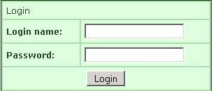 | 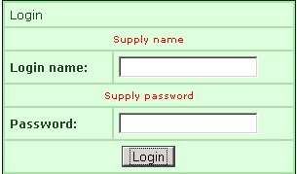
If you fill only the "Login name" field and click Login button without filling the next fields, you will get the output pages as :
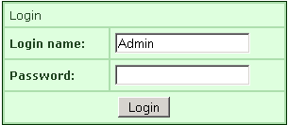 | 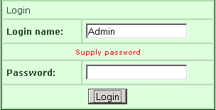
If you fill the wrong information and click the Login button, you will get the output pages as :
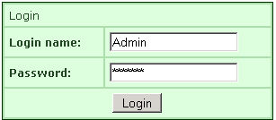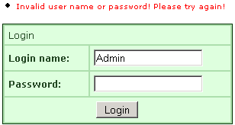
If you fill the correct information and click the Login button, you will get the output pages as :


Login/Logout With Session
In this section, we are going to develop a login/logout application with session. This application checks the user authentication. Whenever you run, it takes a user id and a pas/sword (Both the user id and password is "admin") it displays the welcome page, when both fields are correctly filled.

Create an action mapping in the struts.xml file. Here is the code to be added in the struts.xml:

<action name="login" class="net.roseindia.loginAction" >
<result name="success" type="dispatcher">/pages/uiTags/Success.jsp</result>
<result name="error" type="redirect">/pages/uiTags/Login.jsp</result>
</action>
<action name="logout" class="net.roseindia.logoutAction" >
<result name="success" type="redirect">/pages/uiTags/checkLogin.jsp</result>
</action>
Develop an action class that handles the login request. The Struts 2 framework provides a base ActionSupport class that implements commonly used framework interfaces. In our action class (loginAction.java) we have extended ActionSupport class.
here is the code of "loginAction" action class:
package net.roseindia;
import com.opensymphony.xwork2.ActionSupport;
import com.opensymphony.xwork2.ActionContext;
import java.util.*;
public class loginAction extends ActionSupport {
private String userId;
private String password;
public String execute() throws Exception{
if ("admin".equals(userId) && "admin".equals(password)) {
Map session = ActionContext.getContext().getSession();
session.put("logged-in","true");
return SUCCESS;
}
else{
return ERROR;
}
}
public String logout() throws Exception {
Map session = ActionContext.getContext().getSession();
session.remove("logged-in");
return SUCCESS;
}
public String getPassword() {
return password;
}
public void setPassword(String password) {
this.password = password;
}
public String getUserId() {
return userId;
}
public void setUserId(String userId) {
this.userId = userId;
}
}
Download this code.
Again, develop an action class to handle the logout operation. An action class (logoutAction) we have extended ActionSupport class.
Here is the code of logoutAction action class:
package net.roseindia;
import javax.servlet.http.HttpSession;
import com.opensymphony.xwork2.ActionSupport;
import com.opensymphony.xwork2.ActionContext;
import java.util.*;
public class logoutAction extends ActionSupport {
public String execute() throws Exception {
Map session = ActionContext.getContext().getSession();
session.remove("logged-in");
return SUCCESS;
}
}
Download this code.
Develop Login Form: The GUI of the application consists of login form (Login.jsp). The "Login.jsp" displays the login page to the user.
Here is the code of Login.jsp file:
<%@ taglib prefix="s" uri="/struts-tags" %>
<%@ page language="java" contentType="text/html"%>
<html>
<head>
<title>Insert Data here!</title>
<link href="<s:url value="/css/main.css"/>" rel="stylesheet"
type="text/css"/>
</head>
<body>
<s:form action="/roseindia/login.action" method="POST">
<s:textfield name="userId" label="Login Id"/><br>
<s:password name="password" label="Password"/><br>
<s:submit value="Login" align="center"/>
</s:form>
</body>
</html>
The "Success.jsp" page displays the Login Success message (Welcome, you have logged-in.) and session (Session Time: Wed Aug 01 11:26:38 GMT+05:30 2007 and Logout ) when user gets successful authentication. If you click the "Logout" then again login page is displayed on the screen.
Here is the code of Success.jsp file:
<%@ taglib prefix="s" uri="/struts-tags" %>
<%@ page language="java" contentType="text/html" import="java.util.*"%>
<jsp:include page="/struts2tags/pages/uiTags/loginCheck.jsp" />
<html>
<head>
<title>Welcome, you have logined!</title>
</head>
<body>
Welcome, you have logined. <br />
<b>Session Time: </b><%=new Date(session.getLastAccessedTime())%>
<br /><br />
<a href="<%= request.getContextPath() %>/roseindia/logout.action">Logout</a>
<br />
</body>
</html>
This page logs out the valid user.
checkLogin.jsp
<%@ taglib prefix="s" uri="/struts-tags" %>
<%@ page language="java" contentType="text/html" import="java.util.*"%>
<html>
<head>
<title>Check validate!</title>
</head>
<body>
<s:if test="#session.login != 'admin'">
<jsp:forward page="/pages/uiTags/Login.jsp" />
</s:if>
</body>
</html>
Output:
Run this application by getting the login page:
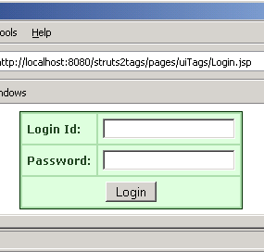
Enter the wrong user id and password in the login page
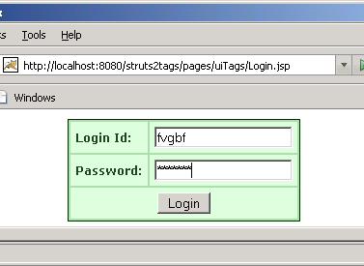
You get the following output:
Enter the correct user id and password in the login page:
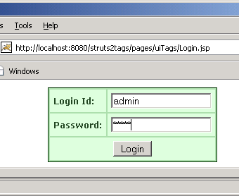
You get the following output:
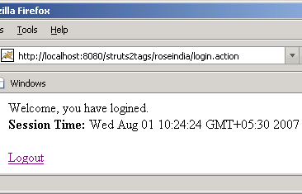
After clicking the "Logout". You get the following output:
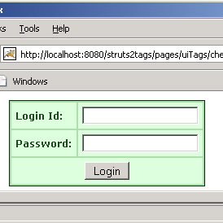

Struts 2 MySQL
In this section, You will learn to connect the MySQL database with the struts 2 application.
Follow the following steps to connect with MySQL database:
Step 1: Create the struts.xml file and add the following xml snippet in the struts.xml file.
<?xml version="1.0" encoding="UTF-8" ?>
<!DOCTYPE struts PUBLIC
"-//Apache Software Foundation//DTD Struts
Configuration 2.0//EN"
"http://struts.apache.org/dtds/struts-2.0.dtd">
<struts>
<!-- Rose India Struts 2 Tutorials -->
<constant name="struts.enable.DynamicMethodInvocation"
value="false" />
<constant name="struts.devMode" value="true" />
<include file="struts-default.xml"/>
<!-- Add packages here -->
<package name="roseindia" namespace="/roseindia"
extends="struts-default">
<!-- inserting data into data base through JDBC -->
<action name="insert">
<result>/pages/insertData.jsp</result>
</action>
<action name="insertData" class="net.roseindia.insert">
<result name="error">/pages/insertData.jsp</result>
<result>/pages/insertSuccess.jsp</result>
</action>
</package>
</struts>
Step 2 : Create an input jsp form.
insertData.jsp
<%@ taglib prefix="s" uri="/struts-tags" %>
<html>
<head>
<title>Struts 2 Insert Data Application!</title>
<link href="<s:url value="/css/main.css"/>" rel="stylesheet"
type="text/css"/>
</head>
<body>
<s:form action="insertData" method="POST" validate="true">
<tr>
<td colspan="2">
Please enter
</td>
</tr>
<s:actionerror />
<s:fielderror />
<s:textfield name="username" label="User Name"/>
<s:password name="password" label="Password"/>
<s:submit value="Save" align="center"/>
</s:form>
</body>
</html>
Step 3 : Create an Action class.
First, Establish a connection with the MySQL Database with the help of MySQL driver ("org.gjt.mm.mysql.Driver").
Now, Make an account in the MySQL database to get connected with the database.
After establishing a connection, you can retrieve, insert and update data to the MySQL database table.
The following action class establishes a connection with MySQL database with the help of appropriate type of methods and API interfaces. If connection is established then the entered data is added to the MySQL database table otherwise it displays an error message.
insert.java
package net.roseindia;
import com.opensymphony.xwork2.ActionSupport;
import java.util.Date;
import java.sql.*;
/**
* <p> Validate a user login. </p>
*/
public class insert extends ActionSupport {
public String execute() throws Exception {
String url = "jdbc:mysql://localhost:3306/";
String dbName = "taskproject";
String driverName = "org.gjt.mm.mysql.Driver";
String userName = "root";
String password = "root";
Connection con=null;
Statement stmt=null;
try{
Class.forName(driverName).newInstance();
con=DriverManager.getConnection(url+dbName, userName,
password);
stmt=con.createStatement();
}
catch(Exception e){
System.out.println(e.getMessage());
}
String uname=getUsername();
String pws=getPassword();
stmt = con.createStatement();
int val = stmt.executeUpdate("INSERT employee VALUES
('"+uname+"','"+pws+"')");
if(val == 0){
return ERROR;
}
else{
return SUCCESS;
}
}
// ---- Username property ----
/**
* <p>Field to store User username.</p>
* <p/>
*/
private String username = null;
/**
* <p>Provide User username.</p>
*
* @return Returns the User username.
*/
public String getUsername() {
return username;
}
/**
* <p>Store new User username</p>
*
* @param value The username to set.
*/
public void setUsername(String value) {
username = value;
}
// ---- Username property ----
/**
* <p>Field to store User password.</p>
* <p/>
*/
private String password = null;
/**
* <p>Provide User password.</p>
*
* @return Returns the User password.
*/
public String getPassword() {
return password;
}
/**
* <p>Store new User password</p>
*
* @param value The password to set.
*/
public void setPassword(String value) {
password = value;
}
}
Description of the code:
Connection:
This is an interface in java.sql package that specifies establishing connection with the specific database like: MySQL, Ms-Access, Oracle etc and java files. The SQL statements are executed within the context of the Connection interface.
Class.forName(String driver):
This method is static. It attempts to load the class dynamically and returns class instance and takes string type value (driver) when it matches with the class with given string.
DriverManager:
It is a class of java.sql package that controls a set of JDBC drivers. Each driver has to be registered with this class.
getConnection(String url, String userName, String password):
This method establishes a connection to specified database url. It takes three string types of arguments like:
url: - Database url to link with
userName: - User name of database
password: -Password of database
con.close():
This method is used for disconnecting the connection. It frees all the resources occupied by the database.
Step 4 : Create the validator
The validation.xml format is either <ActionClassName>-validation.xml or <ActionClassName>-<ActionAliasName>-validation.xml.
insert-validation.xml
<?xml version="1.0" encoding="UTF-8"?>
<!DOCTYPE validators PUBLIC
"-//OpenSymphony Group//XWork Validator 1.0.2//EN"
"http://www.opensymphony.com/xwork/xwork-validator-1.0.2.dtd">
<validators>
<field name="username">
<field-validator type="requiredstring">
<param name="trim">true</param>
<message>User name is required</message>
</field-validator>
</field>
<field name="password">
<field-validator type="requiredstring">
<param name="trim">true</param>
<message>Password is required</message>
</field-validator>
</field>
</validators>
When entered the correct data in the text field the user gets the insertSuccess.jsp page displaying the entered data.
insertSuccess.jsp
<html>
<head>
<title>Inserted Data List</title>
</head>
<body>
<b> Inserted Data: </b>
<b>User name = </b><%=request.getParameter("username") %>!
<b>Password = </b><%=request.getParameter("password") %>!
</body>
</html>
Output:
When this application executes the user gets the following:
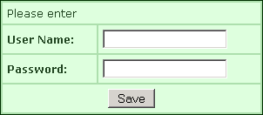
Without filling fields and click "Save" button, you will get the output page as :
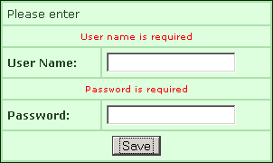
If you fill only the "Password" field and click "Save" button without filling the next fields, you will get the output page as :
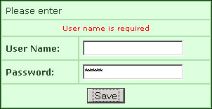
If you fill only the "User Name" field and click "Save" button without filling the next fields, you will get the output page as :
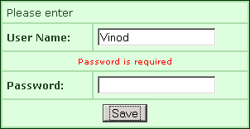
If you fill both field:
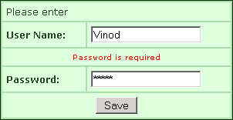
Then you get:

Rich Editor Example
In this section, you will learn how to create pagination in struts 2. For creating pagination in your application follows the certain steps:
Download this code
Step 1: Create index.jsp page
Here is the code to be added in the index.jsp:
<!DOCTYPE HTML PUBLIC "-//W3C//DTD HTML 4.0 Transitional//EN">
<html>
<head>
<title>RoseIndia.Net Struts 2 Tutorial</title>
</head>
<body>
<div align="center">
<center>
<table border="0" cellpadding="0" cellspacing="0" width="400">
<tr>
<td><font color="#000080" size="5"><b>RoseIndia.net Struts 2 Tutorials</b><br>
&nbsp;&nbsp;&nbsp;</font></td>
</tr>
<tr>
<td><font color="#000080"><b>Select the following links to test the
examples</b></font></td>
</tr>
<tr>
<td>
<ul>
<li><a href="roseindia/pagination.action">Pagination Example</a></li>
</ul>
</td>
</tr>
<tr>
<td><font color="#000080">&nbsp;<br>
&nbsp;<br>
&nbsp;<br>
Visit <a href="http://www.roseindia.net">http://www.roseindia.net</a>
for latest tutorials</font></td>
</tr>
</table>
</center>
</div>
<p align="center">&nbsp;</p>
</body>
</html>
Step 2: Create an action mapping in the struts.xml file.
Here is the code to be added in the struts.xml:
<?xml version="1.0" encoding="UTF-8" ?>
<!DOCTYPE struts PUBLIC
"-//Apache Software Foundation//DTD Struts Configuration 2.0//EN"
"http://struts.apache.org/dtds/struts-2.0.dtd">
<struts>
<!-- Rose India Struts 2 Tutorials -->
<constant name="struts.enable.DynamicMethodInvocation" value="false" />
<constant name="struts.devMode" value="true" />
<package name="roseindia" namespace="/roseindia" extends="struts-default">
<action name="pagination">
<result>/pages/chatQuestion/pagination.jsp</result>
</action>
</package>
<!-- Add packages here -->
</struts>
Step 3: Create a JSP page that contains pagination code:
Here is the code to be added in the pagination.jsp:
<%@ taglib prefix="s" uri="/struts-tags" %>
<html>
<head>
<title>Pagination Example</title>
<s:head theme="ajax" />
</head>
<body>
<s:form>
<s:textarea name="text" label="Paste your text here" theme="ajax"
cssStyle="background-color: #FCFCFC; border: 1px solid #A0A0A0; min-height:500px; max-height:inherit; "/>
</s:form>
</body>
</html>
Output:
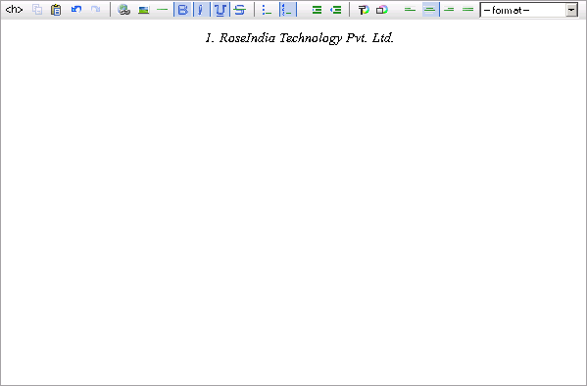

Validate TextArea
In this section, you will learn how to validate your text area in struts 2. A text area contains 1 to 250 characters. It cann't support "null" value.
For validating your text are in your application follows the certain steps:
Step 1: Create index.jsp page
Here is the code to be added in the index.jsp:
<!DOCTYPE HTML PUBLIC "-//W3C//DTD HTML 4.0 Transitional//EN">
<html>
<head>
<title>RoseIndia.Net Struts 2 Tutorial</title>
</head>
<body>
<div align="center">
<center>
<table border="0" cellpadding="0" cellspacing="0" width="400">
<tr>
<td><font color="#000080" size="5"><b>RoseIndia.net Struts 2 Tutorials</b><br>
&nbsp;&nbsp;&nbsp;</font></td>
</tr>
<tr>
<td><font color="#000080"><b>Select the following links to test the
examples</b></font></td>
</tr>
<tr>
<td>
<ul>
<li><a href="roseindia/characterLimit.action">Characters and limiting Example</a></li>
</ul>
</td>
</tr>
<tr>
<td><font color="#000080">&nbsp;<br>
&nbsp;<br>
&nbsp;<br>
Visit <a href="http://www.roseindia.net">http://www.roseindia.net</a>
for latest tutorials</font></td>
</tr>
</table>
</center>
</div>
<p align="center">&nbsp;</p>
</body>
</html>
Step 2: Create an action mapping in the struts.xml file.
Here is the code to be added in the struts.xml:
<?xml version="1.0" encoding="UTF-8" ?>
<!DOCTYPE struts PUBLIC
"-//Apache Software Foundation//DTD Struts Configuration 2.0//EN"
"http://struts.apache.org/dtds/struts-2.0.dtd">
<struts>
<!-- Rose India Struts 2 Tutorials -->
<constant name="struts.enable.DynamicMethodInvocation" value="false" />
<constant name="struts.devMode" value="true" />
<package name="roseindia" namespace="/roseindia" extends="struts-default">
<action name="characterLimit">
<result>/pages/chatQuestion/limitedCharacter.jsp</result>
</action>
<action name="characterLimit1" class="net.roseindia.limitedCharacterAction">
<result name="error">/pages/chatQuestion/limitedCharacter.jsp</result>
<result name="success">/pages/chatQuestion/limitedCharacterSuccess.jsp</result>
</action>
</package>
<!-- Add packages here -->
</struts>
Step 3: Create a JSP page that contains text area and submit button:
Here is the code to be added in the limitedCharacter.jsp:
<%@ taglib prefix="s" uri="/struts-tags" %>
<html>
<head>
<title>Limited Characters in Text Area</title>
<s:head theme="ajax" />
</head>
<body>
<s:form action="characterLimit1" method="POST" validate="true">
<s:textarea name="summary1" label="Brief Summary" rows="6" cols="40"/>
<s:submit value="Save" align="center" />
</s:form>
</body>
</html>
Step 4: Create an action class:
Here is the code to be added in thelimitedCharacterAction.java:
package net.roseindia;
import com.opensymphony.xwork2.ActionContext;
import com.opensymphony.xwork2.ActionSupport;
import java.io.PrintStream;
import java.util.List;
import java.util.*;
public class limitedCharacterAction extends ActionSupport{
private String summary1;
public String getSummary1() {
return summary1;
}
public void setSummary1(String summary1) {
this.summary1 = summary1;
}
public String execute() throws Exception{
String summaryText = getSummary1();
long countSummaryText = summaryTextcount(summaryText);
System.out.println("countSummaryText:"+countSummaryText);
if (countSummaryText >0 && countSummaryText < 250){
return SUCCESS;
}
else{
if(getSummary1().equals(""))
addFieldError("summary1","Brief Summary is required.");
if((countSummaryText > 250))
addFieldError("summary1","Brief Summary must be 1 to 250 Charaters");
return ERROR;
}
}
private static long summaryTextcount(String str){
return str.length();
}
}
Step 5: Create a JSP page that contains the inputted text in the textarea:
Here is the code to be added in limitedCharacterSuccess.jsp:
<%@ taglib prefix="s" uri="/struts-tags"%>
<html>
<head>
<title>Limited Characters in Text Area</title>
<link href="<s:url value="/css/main.css"/>" rel="stylesheet"
type="text/css"/>
</head>
<body>
<b>Brief Summary: </b><s:property value="summary1" /><br>
</body>
</html>
Output:
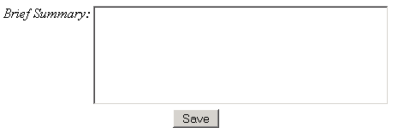
When you click the "Save" command button with out any data then you get:
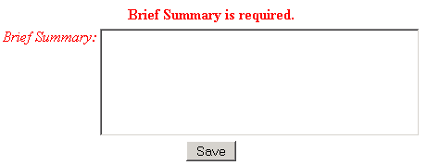
If you enter more than 250 characters then you get :
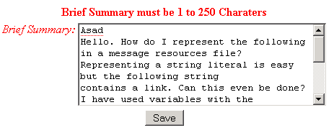
If you enter your text between 1 to 250 characters then you get:
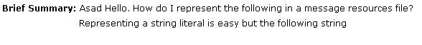

Struts 2 Tags
In this section we will introduce you with the tags provided along with Struts 2 framework. It is necessary to understand all the tags provided along with Struts 2 framework. In this page we will have listed all the Struts 2 Tags and in subsequent sections we will provide you the examples of the these tags in detail.

The Struts 2 Tags can be divided into two types:

- Struts Generic Tags
The struts generic tags are used to control the execution flow when pages are rendered. Another use of struts generic tags are data extraction.
Further Generic Tags are classified into Control Tags and Data Tags.
Control Tags: The Control Tags are used for flow control, such as if, else and iterate.
Here are the list of Control Tags:
* if
* elseIf
* else
* append
* generator
* iterator
* merge
* sort
* subset
Data Tags: The Data Tags are used for data manipulation or creation, such as bean, push, and i18n.
Here are the list of Data Tags:
* a
* action
* bean
* date
* debug
* i18n
* include
* param
* push
* set
* text
* url
* property
- Struts UI tags
Struts UI Tags are mainly designed to use the data from your action/value stack or from Data Tags. These tags are used to display the data on the HTML page. The UI tags are driven by templates and themes.
Struts UI Tags are of two types Form Tags and Non - Form tags.
Form Tags are as follows:
* autocompleter
* checkbox
* checkboxlist
* combobox
* datetimepicker
* doubleselect
* head
* file
* form
* hidden
* label
* optiontransferselect
* optgroup
* password
* radio
* reset
* select
* submit
* textarea
* textfield
* token
* updownselect
Non-Form UI Tags are:
* actionerror
* actionmessage
* component
* div
* fielderror
* table
* tabbedPanel
* tree
* treenode
The main difference between Struts Generic Tags and Struts UI Tags are:
- The generic tags simply output some content directly from the tag while the UI tags uses templates and often group the output together with theme

Control Tags-If / Else If / Else
In this section we are going to discuss the various control tags ( The Control Tags are used for flow control such as if, else and iterate.)
'If' tag could be used by itself or with 'Else If' Tag and/or single/multiple 'Else' Tag.
Create a JSP page IfControlTag.jsp.
Set a property 'technologyName' with a value 'Java' as <s:set name="technologyName" value="%{'Java'}"/>
Among if, elseif and else tags only one tag evaluates at a time. Evaluation is based upon the conditions being processed. Evaluated conditions must be of Boolean type. This is illustrated in the following Jsp page.
[Note:
If the condition in <s:if > tag evaluates to 'true' then only this tag is evaluated and others are discarded. As illustrated in the example.
If the condition in <s:if > tag evaluates to 'false' and <s:elseif > tag evaluates to 'true' then the body of the <s:elseif > tag is processed.
If the condition in <s:if > tag and <s:elseif > tags evaluates to 'false' then only the <s:else > tag is processed. ]
IfControlTag.jsp
<%@ taglib prefix="s" uri="/struts-tags" %>
<html>
<head>
<title>Struts 2 Control Tag Example</title>
</head>
<body>
<s:set name="technologyName" value="%{'Java'}"/>
<s:if test="%{#technologyName=='Java'}">
<div><s:property value="%{#technologyName}" /></div>
</s:if>
<s:elseif test="%{#technologyName=='Jav'}">
<div><s:property value="%{#technologyName}" /></div>
</s:elseif>
<s:else>
<div>Technology Value is not Java</div>
</s:else>
</body>
</html>
struts.xml: Add the following xml snippet in the struts.xml file.
<action name="doIf" >
<result>/pages/genericTags/IfControlTag.jsp</result>
</action>
index.jsp : Add the following jsp snippet in the index.jsp file.
<ul>
<li><a href="roseindia/doIf.action">IF Control Tag Example</a></li>
</ul>
In the IfControlTag.jsp only <s:if> tag evaluates to true
<s:if test="%{#technologyName=='Java'}">
<div><s:property value="%{#technologyName}" /></div>
</s:if>
So we get the output equal to Java
Java

Append Tag (Control Tags) Example
In this section, we are going to describe the append tag. The append tag is a generic tag that is used to merge multiple iterators into one iterator.
Append Iterator Tag is used to append iterators to form an appended iterator through which the entries goes from one iterator to another after each respective iterator is exhausted of entries.
Add the following code snippet into the struts.xml file.
struts.xml :
<action name="AppendTag" class="net.roseindia.AppendTag">
<result>/pages/genericTags/AppendTag.jsp</result>
</action>
Create two lists in the action class and populate them with various items as shown in the "AppendTag" class.
AppendTag.java
package net.roseindia;
import com.opensymphony.xwork2.ActionSupport;
import java.util.*;
public class AppendTag extends ActionSupport{
private List myList;
private List myList1;
public String execute()throws Exception{
myList = new ArrayList();
myList.add("www.Roseindia.net");
myList.add("Deepak Kumar");
myList.add("Sushil Kumar");
myList.add("Vinod Kumar");
myList.add("Amit Kumar");
myList1 = new ArrayList();
myList1.add("www.javajazzup.com");
myList1.add("Himanshu Raj");
myList1.add("Mr. khan");
myList1.add("John");
myList1.add("Ravi Ranjan");
return SUCCESS;
}
public List getMyList(){
return myList;
}
public List getMyList1(){
return myList1;
}
}
Now create a jsp page using <s:append> and <s:iterator> tags as shown in the AppendTag.jsp page. The append tag is used to merge multiple iterators into one iterator. The "id" parameter keeps the resultant appended iterator stored under the stack's context and the "value" parameter is used to get the values contained within the resultant iterator.
AppendTag.jsp
<%@ taglib prefix="s" uri="/struts-tags" %>
<html>
<head>
<title> Append Tag Example!</title>
</head>
<body>
<h1><span style="background-color: #FFFFcc"> Append Tag Example!</span></h1>
<s:append id="myAppendList">
<s:param value="%{myList}" />
<s:param value="%{myList1}" />
</s:append>
<s:iterator value="%{#myAppendList}">
<s:property /><br>
</s:iterator>
</body>
</html>
Output of the Append Tag Example:
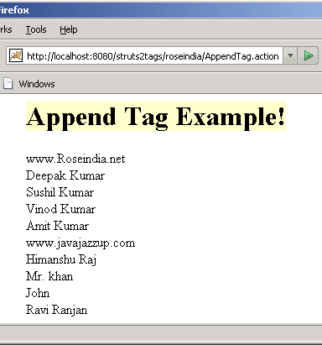

Generator Tag (Control Tags) Example
In this section, we are going to describe the generator tag. The generator tag is a generic tag that is used to generate iterators based on different attributes passed. Here we will not pass any attribute.
Add the following code snippet into the struts.xml file.
sturts.xml
<action name="GeneratorTag" class="net.roseindia.GeneratorTag">
<result>/pages/genericTags/GeneratorTag.jsp</result>
</action>
Create an action class as shown:
GeneratorTag.java
package net.roseindia;
import com.opensymphony.xwork2.ActionSupport;
import org.apache.struts2.util.IteratorGenerator.Converter;
public class GeneratorTag extends ActionSupport {
public String excute() throws Exception{
return SUCCESS;
}
}
Create a jsp page where the generator tag <s:generator> generates a simple iterator based on the val attribute supplied and <s:iterator> tag prints it out using the <s:property /> tag. The separator attribute is used to separate the val into entries of the iterator.
GeneratorTag.jsp
<%@ taglib prefix="s" uri="/struts-tags" %>
<html>
<head>
<title> Generator Tag Example! </title>
</head>
<body>
<h1><span style="background-color: #FFFFcc">Generator Tag Example!
</span></h1>
<h3><font color="#0000FF"> Generates a Simple Iterator </font></h3>
<s:generator val="%{'www.Roseindia.net,Deepak Kumar,Sushil Kumar,
Vinod Kumar,Amit Kumar'}" separator=",">
<s:iterator>
<s:property /><br/>
</s:iterator>
</s:generator>
</body>
</html>
Output of Generator Tag Example:
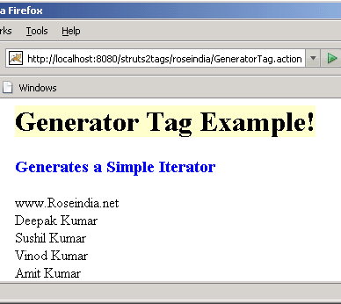

Generator Tag (Control Tags) Using Count Attributes
In this section, we are going to describe the generator tag using the count attribute.
Add the following code snippet into the struts.xml file.
struts.xml
<action name="GeneratorTagCountAttribute" class="net.roseindia.GeneratorTag">
<result>/pages/genericTags/GeneratorTagCountAttribute.jsp</result>
</action>
Create an action class as shown:
GeneratorTag.java
package net.roseindia;
import com.opensymphony.xwork2.ActionSupport;
import org.apache.struts2.util.IteratorGenerator.Converter;
public class GeneratorTag extends ActionSupport {
public String excute() throws Exception{
return SUCCESS;
}
}
Create a jsp page where the generator tag <s:generator> generates an iterator with "count" attribute and <s:iterator> tag prints it out using the <s:property /> tag. The separator attribute separates the val into entries of the iterator.
This generates an iterator, but only 5 entries will be available in the iterator generated, namely 'www.Roseindia.net, Deepak Kumar, Sushil Kumar, Vinod Kumar, Amit Kumar' respectively because count attribute is set to 5.
GeneratorTagCountAttribute.jsp
<%@ taglib prefix="s" uri="/struts-tags" %>
<html>
<head>
<title> Generator Tag Example! </title>
</head>
<body>
<h1><span style="background-color: #FFFFcc">Generator Tag Example!</span></h1>
<h3><font color="#0000FF"> Generates an Iterator With Count Arrtibute</font></h3>
<s:generator val="%{'www.Roseindia.net,Deepak Kumar,Sushil Kumar,Vinod Kumar,
Amit Kumar, Sanjay, Vijay '}" count="5" separator=",">
<s:iterator>
<s:property /><br/>
</s:iterator>
</s:generator>
</body>
</html>
Output of the Generator Tag Example:
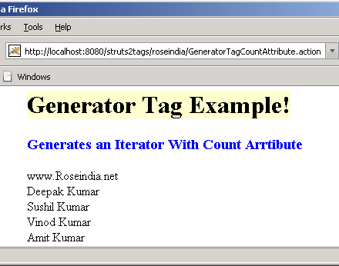

Generator Tag (Control Tags) Using an Iterator with Id Attributes
In this section, we are going to describe the generator tag using the id attributes.
Add the following code snippet into the struts.xml file.
struts.xml
<action name="GeneratorTagIdAttribute" class="net.roseindia.GeneratorTag">
<result>/pages/genericTags/GeneratorTagIdAttribute.jsp</result>
</action>
Create an action class as shown :
GeneratorTag.java
package net.roseindia;
import com.opensymphony.xwork2.ActionSupport;
import org.apache.struts2.util.IteratorGenerator.Converter;
public class GeneratorTag extends ActionSupport {
public String excute() throws Exception{
return SUCCESS;
}
}
Create a jsp page where the generator tag <s:generator> generates an iterator with "id" attribute and <s:iterator> tag prints it out using the <s:property /> tag. The separator attribute separates the val into entries of the iterator.
The scriplet as shown below generates an iterator and put it in the PageContext under the key as specified
by the id attribute.
<%
Iterator i = (Iterator) pageContext.getAttribute("myAtt");
while(i.hasNext()) {
String s = (String) i.next(); %>
<%=s%> <br/>
<% }
%>
GeneratorTagIdAttribute.jsp
<%@ taglib prefix="s" uri="/struts-tags" %>
<%@page language="java" import="java.util.*"%>
<html>
<head>
<title> Generator Tag Example! </title>
</head>
<body>
<h1><span style="background-color

: #FFFFcc">Generator Tag Example!</span></h1>
<h3><font color="#0000FF"> Generates an Iterator With Id Arrtibute</font></h3>
<s:generator val="%{'www.Roseindia.net,Deepak Kumar,Sushil Kumar,Vinod
Kumar,Amit Kumar'}" count="4" separator="," id="myAtt" />
<%
Iterator i = (Iterator) pageContext.getAttribute("myAtt");
while(i.hasNext()) {
String s = (String) i.next(); %>
<%=s%> <br/>
<% }
%>
</body>
</html>
Output of the Generator Tag Example:
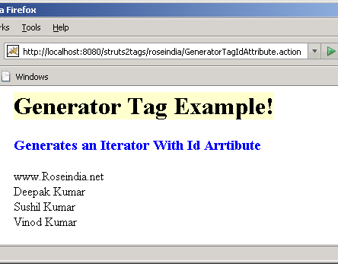

Iterator Tag (Control Tags) Example
In this section, we are going to describe the Iterator tag. Iterator tag is used to iterate over a value. An iterable value can be either of: java.util.Collection, java.util.Iterator.
Add the following code snippet into the struts.xml file.
struts.xml
<action name="iteratorTag" class="net.roseindia.iteratorTag">
<result>/pages/genericTags/iteratorTag.jsp</result>
</action>
Create an action class as shown:
iteratorTag.java
package net.roseindia;
import com.opensymphony.xwork2.ActionSupport;
import java.util.*;
public class iteratorTag extends ActionSupport{
private List myList;
public String execute()throws Exception{
myList = new ArrayList();
myList.add("Fruits");
myList.add("Apple");
myList.add("Mango");
myList.add("Orange");
myList.add("Pine Apple");
return SUCCESS;
}
public List getMyList(){
return myList;
}
}
The following example retrieves the value of the getMyList() method of the current object on the value stack and uses it to iterate over. The <s:property/> tag prints out the current value of the iterator.
iteratorTag.jsp
<%@ taglib prefix="s" uri="/struts-tags" %>
<html>
<head>
<title>Iterator Tag Example!</title>
</head>
<body>
<h1><span style="background-color: #FFFFcc">Iterator Tag Example!</span></h1>
<s:iterator value="myList">
<s:property /><br>
</s:iterator>
</body>
</html>
Output of An Iterator Tag Example:
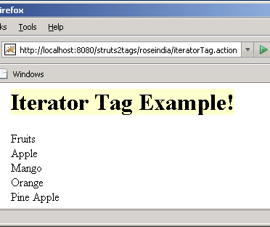

Merge Tag (Control Tags) Example
In this section, we are going to describe the merge tag. The merge tag is a generic tag that is used to merge iterators. The successive call to the merge iterator causes each merge iterator to have a chance to expose its element, subsequently next call allows the next iterator to expose its element. Once the last iterator is done exposing its element, the first iterator is allowed to do so again (unless it is exhausted of entries).
In the current example, 2 lists being merged, each list have 5 entries, the following will be the logic.
- Display first element of the first list.
- Display first element of the second list.
- Display second element of the first list.
- Display second element of the second list.
- Display third element of the first list.
- Display thrid element of the second list.....and so on.
Add the following code snippet into the struts.xml file.
struts.xml
<action name="mergeTag" class="net.roseindia.mergeTag">
<result>/pages/genericTags/mergeTag.jsp</result>
</action>
Create two lists in the action class and populate them with various items as shown in the "mergeTag" class.
mergeTag.java
package net.roseindia;
import com.opensymphony.xwork2.ActionSupport;
import java.util.*;
public class mergeTag extends ActionSupport {
private List myList;
private List myList1;
public String execute() throws Exception{
myList = new ArrayList();
myList.add("www.Roseindia.net");
myList.add("Deepak Kumar");
myList.add("Sushil Kumar");
myList.add("Vinod Kumar");
myList.add("Amit Kumar");
myList1 = new ArrayList();
myList1.add("www.javajazzup.com");
myList1.add("Himanshu Raj");
myList1.add("Mr. khan");
myList1.add("John");
myList1.add("Ravi Ranjan");
return SUCCESS;
}
public List getMyList(){
return myList;
}
public List getMyList1(){
return myList1;
}
}
Now create a jsp page using <s:merge> and <s:param value> tags as shown in the mergeTag.jsp page. The merge tag is used to merge iterators. The "id" parameter keeps the resultant iterator stored under in the stack's context and the "value" parameter in the <s:iterator> is used to get the values contained within the respective iterators.
mergeTag.jsp
<%@ taglib prefix="s" uri="/struts-tags" %>
<html>
<head>
<title>Merge Tag Example!</title>
</head>
<body>
<h1><span style="background-color: #FFFFcc">Merge Tag Example!</span></h1>
<s:merge id="mergeId">
<s:param value="%{myList}" />
<s:param value="%{myList1}" />
</s:merge>
<s:iterator value="%{#mergeId}">
<s:property /><br>
</s:iterator>
</body>
</html>
Output of merge Tag:
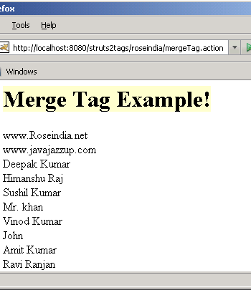

Subset Tag (Control Tags) Example
In this section, we are going to describe the subset tag. The subset tag is a generic tag that takes an iterator and outputs a subset of it. It delegates to org.apache

.struts2.util.SubsetIteratorFilter internally to perform the subset functionality.
Add the following code snippet into the struts

.xml file.
struts.xml
<action name="subsetTag" class="net.roseindia.subsetTag">
<result>/pages/genericTags/subsetTag.jsp</result>
</action>
Create a list in the action class and populate it with various items as shown in the "subsetTag" class.
subsetTag.java
package net.roseindia;
import com.opensymphony.xwork2.ActionSupport;
import java.util.*;
public class subsetTag extends ActionSupport {
private List myList;
public String execute() throws Exception{
myList = new ArrayList();
myList.add(new Integer(50));
myList.add(new Integer(20));
myList.add(new Integer(100));
myList.add(new Integer(85));
myList.add(new Integer(500));
return SUCCESS;
}
public List getMyList(){
return myList;
}
}
Now create a jsp page using <s:subset> and <s:iterator> tags as shown in the subsetTag.jsp page. The subset tag takes an iterator and outputs a subset of it.
subsetTag.jsp
<%@ taglib prefix="s" uri="/struts-tags" %>
<html>
<head>
<title>Subset Tag Example!</title>
</head>
<body>
<h1><span style="background-color: #FFFFcc">Subset Tag Example!</span></h1>
<s:subset source="myList">
<s:iterator>
<s:property /><br>
</s:iterator>
</s:subset>
</body>
</html>
Output of Subset Tag:
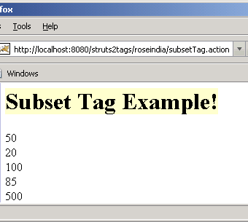

Subset Tag (Control Tags) Example Using Count
In this section, we are going to describe the subset tag using the count parameter. The count parameter indicates the number of entries to be set in the resulting subset iterator.
Add the following code snippet into the struts.xml file.
struts.xml
<action name="subsetTagCount" class="net.roseindia.subsetTag">
<result>/pages/genericTags/subsetTagCount.jsp</result>
</action>
Create a list in the action class and populate it with various items as shown in the "subsetTag" class.
subsetTag.java
package net.roseindia;
import com.opensymphony.xwork2.ActionSupport;
import java.util.*;
public class subsetTag extends ActionSupport {
private List myList;
public String execute() throws Exception{
myList = new ArrayList();
myList.add(new Integer(50));
myList.add(new Integer(20));
myList.add(new Integer(100));
myList.add(new Integer(85));
myList.add(new Integer(500));
return SUCCESS;
}
public List getMyList(){
return myList;
}
}
Now create a jsp page using <s:subset> and <s:iterator> tags as shown in the subsetTag.jsp page. The subset tag takes an iterator and outputs a subset of it. The parameter count is of integer type and it sets the number of entries to be kept in the resulting subset iterator.
subsetTagCount.jsp
<%@ taglib prefix="s" uri="/struts-tags" %>
<html>
<head>
<title>Subset Tag Example!</title>
</head>
<body>
<h1><span style="background-color: #FFFFcc">Subset Tag Example!</span></h1>
<s:subset source="myList" count="3">
<s:iterator>
<s:property /><br>
</s:iterator>
</s:subset>
</body>
</html>
Output of Subset Tag:
Output displays only three items because count=3.
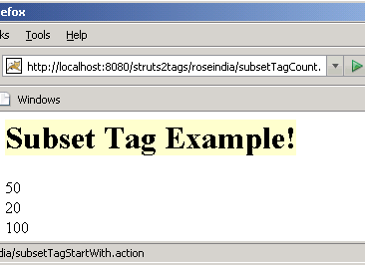

Subset Tag (Control Tags) Example Using Start
In this section, we are going to describe the subset tag using the start parameter. The start parameter is of integer type. It indicates the starting index (eg. first entry is 0) of entries in the source (needed to make available as the first entry in the resulting subset iterator).
Add the following code snippet into the struts.xml file.
struts.xml
<action name="subsetTagStartWith" class="net.roseindia.subsetTag">
<result>/pages/genericTags/subsetTagStartWith.jsp</result>
</action>
Create a list in the action class and populate it with various items as shown in "subsetTag" class.
subsetTag.java
package net.roseindia;
import com.opensymphony.xwork2.ActionSupport;
import java.util.*;
public class subsetTag extends ActionSupport {
private List myList;
public String execute() throws Exception{
myList = new ArrayList();
myList.add(new Integer(50));
myList.add(new Integer(20));
myList.add(new Integer(100));
myList.add(new Integer(85));
myList.add(new Integer(500));
return SUCCESS;
}
public List getMyList(){
return myList;
}
}
Now create a jsp page using <s:subset> and <s:iterator> tags as shown in the subsetTag.jsp page. The subset tag takes an iterator and outputs a subset of it. The parameter start is of integer type and it indicates the starting index (eg. first entry is 0) of entries in the source (needed to make available as the first entry in the resulting subset iterator).
subsetTagStartWith.jsp
<%@ taglib prefix="s" uri="/struts-tags" %>
<html>
<head>
<title>Subset Tag Example!</title>
</head>
<body>
<h1><span style="background-color: #FFFFcc">Subset Tag Example!</span></h1>
<s:subset source="myList" count="3" start="2">
<s:iterator>
<s:property /><br>
</s:iterator>
</s:subset>
</body>
</html>
Output of Subset Tag:
Here the items displayed are 100, 85, 500. Items displayed starts from 2nd index of the List.
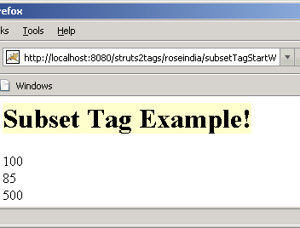

Action Tag (Data Tag) Example
In this section, we are going to describe the action tag. The action tag is a generic tag that is used to call actions directly from a JSP page by specifying the action name and an optional namespace. The body content of the tag is used to render the results from the Action. Any result processor

defined for this action in struts.xml will be ignored, unless the executeResult parameter is specified.
Add the following code snippet into the struts.xml file.
struts.xml
<action name="actionTag" class="net.roseindia.actionTag">
<result name="success">/pages/genericTags/success.jsp</result>
</action>
Create an action class as shown below:
actionTag.java
package net.roseindia;
import com.opensymphony.xwork2.ActionSupport;
public class actionTag extends ActionSupport {
public String execute() throws Exception{
return SUCCESS;
}
}
Now create a jsp page using <s:action> tag as shown in the success.jsp page. The action tag is used to call actions directly from a JSP page by specifying the action name and an optional namespace.
success.jsp
<%@ taglib prefix="s" uri="/struts-tags" %>
<html>
<head>
<title>Action Tag Example!</title>
</head>
<body>
<h1><span style="background-color: #FFFFcc">Action Tag
(Data Tags) Example!</span></h1>
<s:action name="success">
<b><i>The action tag will execute the result and include
it in this page.</i></b></div>
</s:action>
</body>
</html>
Output of the success.jsp
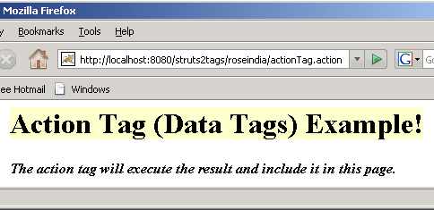

Bean Tag (Data Tag) Example
In this section, we are going to describe the Bean Tag. The Bean tag is a generic tag that is used to instantiates a class that confirms to the JavaBeans specification. This tag has a body which can contain a number of Param elements to set any mutator methods on that class.
If the id attribute is set on the BeanTag, it will place the instantiated bean into the stack's Context.
Add the following code snippet into the struts.xml file.
struts.xml
<action name="beanTag" class="net.roseindia.beanTag">
<result name="success">/pages/genericTags/beanTag.jsp</result>
</action>
Create an action class as shown below:
beanTag.java
package net.roseindia;
import com.opensymphony.xwork2.ActionSupport;
public class beanTag extends ActionSupport {
public String execute() throws Exception{
return SUCCESS;
}
}
create a simple java bean as shown:
companyName.java
package net.roseindia;
public class companyName {
private String name;
public void setName(String name){
this.name =name ;
}
public String getName(){
return name;
}
}
Now create a jsp page using <s:bean> and <s:param> tags as shown in the beanTag.jsp page. The bean tag instantiates the "net.roseindia.companyName" class, it confirms to the JavaBeans specification. The id attribute is set on the BeanTag, it places the instantiated bean into the stack's Context. The body of <s:bean> tag contains a param element
<s:param name="name">RoseIndia</s:param> which is used to set the value for the setName() method of the "companyName" class and <s:property value="%{name}" /> retrieves that value by calling the getName() method.
beanTag.jsp
<%@ taglib prefix="s" uri="/struts-tags" %>
<html>
<head>
<title>Bean Tag Example!</title>
</head>
<body>
<h1><span style="background-color: #FFFFcc">Bean Tag
(Data Tags) Example!</span></h1>
<s:bean name="net.roseindia.companyName" id="uid">
<s:param name="name">RoseIndia</s:param>
<s:property value="%{name}" /><br>
</s:bean>
</body>
</html>
Output of the beanTag.jsp
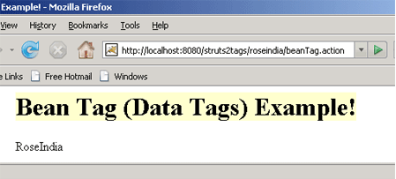

Date Tag (Data Tag) Example
In this section, we are going to describe the Date tag. The date tag allows to format a Date in a quick and easy way. User can specify a custom format (eg. "dd/MM/yyyy hh:mm"), can generate easy readable notations (like "in 2 hours, 14 minutes"), or can just fall back on a predefined format with key 'struts.date.format' in the properties file.
If that key is not defined, it will finally fall back to the default DateFormat.MEDIUM formatting.
Note: If the requested Date object isn't found on the stack, a blank will be returned.
Configurable attributes are :-
- name
- nice
- format
Add the following code snippet into the "struts.xml" file.
struts.xml
<action name="dateTag" class="net.roseindia.dateTag">
<result name="success">/pages/genericTags/dateTag.jsp</result>
</action>
Create an action class as shown below:
dateTag.java
package net.roseindia;
import com.opensymphony.xwork2.ActionSupport;
import java.util.*;
public class dateTag extends ActionSupport {
private Date currentDate;
public String execute() throws Exception{
setCurrentDate(new Date());
return SUCCESS;
}
public void setCurrentDate(Date date){
this.currentDate = date;
}
public Date getCurrentDate(){
return currentDate;
}
}
Now create a jsp page using <s:date> tag as shown in the success.jsp page.
The <s:date name="currentDate" format="dd/MM/yyyy" /> date tag formats a Date in a quick and easy way. Here the "format" parameter specify a custom format (eg. "dd/MM/yyyy hh:mm") to follow.
The nice parameter is of Boolean type which decides whether to print out the date nicely or not. By Default it is kept false which prints out date nicely i.e. <s:date name="currentDate" nice="false" /> tag formats a date and similarly <s:date name="currentDate" nice="true" /> does not format a date, it is illustrated in our current jsp page.
dateTag.jsp
<%@ taglib prefix="s" uri="/struts-tags" %>
<html>
<head>
<title>Date Tag (Data Tag) Example!</title>
</head>
<body>
<h1><font color="#000080">Current Date Format</font></h1>
<table border="1" width="35%" bgcolor="ffffcc">
<tr>
<td width="50%"><b><font color="#000080">Date Format</font></b></td>
<td width="50%"><b><font color="#000080">Date</font></b></td>
</tr>
<tr>
<td width="50%">Day/Month/Year</td>
<td width="50%"><s:date name="currentDate" format="dd/MM/yyyy" /></td>
</tr>
<tr>
<td width="50%">Month/Day/Year</td>
<td width="50%"><s:date name="currentDate" format="MM/dd/yyyy" /></td>
</tr>
<tr>
<td width="50%">Month/Day/Year</td>
<td width="50%"><s:date name="currentDate" format="MM/dd/yy" /></td>
</tr>
<tr>
<td width="50%">Month/Day/Year Hour<B>:</B>Minute</td>
<td width="50%"><s:date name="currentDate" format="MM/dd/yy hh:mm" /></td>
</tr>
<tr>
<td width="50%">Month/Day/Year Hour<B>:</B>Minute<B>:</B>Second</td>
<td width="50%"><s:date name="currentDate" format="MM/dd/yy hh:mm:ss" /></td>
</tr>
<tr>
<td width="50%">Nice Date (Current Date & Time)</td>
<td width="50%"><s:date name="currentDate" nice="false" /></td>
</tr>
<tr>
<td width="50%">Nice Date</td>
<td width="50%"><s:date name="currentDate" nice="true" /></td>
</tr>
</table>
</body>
</html>
Output of the dateTag.jsp :
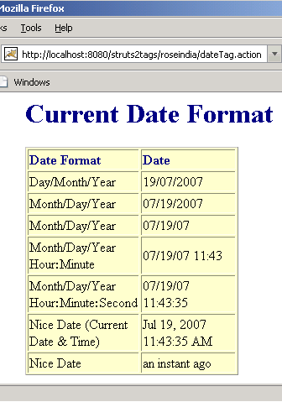

Include Tag (Data Tag) Example
In this section, we are going to describe the include tag. The include tag is a generic tag that is used to include a servlet's output (result of servlet or a JSP page) to the current page.
Add the following code snippet into the struts.xml file.
struts.xml
<action name="includeTag" class="net.roseindia.includeTag">
<result name="success">/pages/genericTags/includeTag.jsp</result>
</action>
Create an action class as shown below:
includeTag.java
package net.roseindia;
import com.opensymphony.xwork2.ActionSupport;
import java.util.*;
public class includeTag extends ActionSupport {
private Date myBirthday;
public String execute() throws Exception{
setMyBirthday(new Date("Jan 12, 1984 11:21:30 AM"));
return SUCCESS;
}
public Date getMyBirthday(){
return myBirthday;
}
}
Create a simple jsp (myBirthday.jsp) that we want to include in our main jsp page ie..includeTag.jsp.
myBirthday.jsp
<%@ taglib prefix="s" uri="/struts-tags" %>
<html>
<head>
<title>Include Tag (Data Tag) Example!</title>
</head>
<body>
<b><font color="#000080">My Birth Day (Date Format)</font></b>
<table border="1" width="35%" bgcolor="ffffcc">
<tr>
<td width="50%"><b><font color="#000080">Date Format</font></b></td>
<td width="50%"><b><font color="#000080">Date</font></b></td>
</tr>
<tr>
<td width="50%">Day/Month/Year</td>
<td width="50%"><s:date name="myBirthday" format="dd/MM/yyyy" /></td>
</tr>
<tr>
<td width="50%">Month/Day/Year</td>
<td width="50%"><s:date name="myBirthday" format="MM/dd/yyyy" /></td>
</tr>
<tr>
<td width="50%">Month/Day/Year</td>
<td width="50%"><s:date name="myBirthday" format="MM/dd/yy" /></td>
</tr>
<tr>
<td width="50%">Month/Day/Year Hour<B>:</B>Minute</td>
<td width="50%"><s:date name="myBirthday" format="MM/dd/yy hh:mm" /></td>
</tr>
<tr>
<td width="50%">Month/Day/Year Hour<B>:</B>Minute<B>:</B>Second</td>
<td width="50%"><s:date name="myBirthday" format="MM/dd/yy hh:mm:ss" /></td>
</tr>
<tr>
<td width="50%">Nice Date (Current Date & Time)</td>
<td width="50%"><s:date name="myBirthday" nice="false" /></td>
</tr>
</table>
</body>
</html>
Now create a jsp page using <s:include> tag as shown in the includeTag.jsp page. The <s:include value="myBirthday.jsp" />
tag includes another jsp using the value parameter
includeTag.jsp
<%@ taglib prefix="s" uri="/struts-tags" %>
<html>
<head>
<title>Include Tag Example!</title>
</head>
<body>
<h1><span style="background-color: #FFFFcc">Include Tag (Data Tags)
Example!</span></h1>
<s:include value="myBirthday.jsp" />
</body>
</html>
Output of the includeTag.jsp :
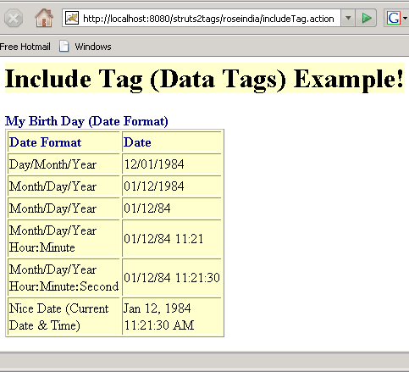

Param Tag (Data Tag) Example
In this section, we are going to describe the param tag. The param tag is a generic tag that is used to parameterize other tags. For example the include tag and bean tag. The parameters can be added with or without a name as a key.
The param tag has the following two parameters.
- name (String) - the name of the parameter
- value (Object) - the value of the parameter
Note: When you declare the param tag, the value can be defined in either a value attribute or as text between the start and end tag.
Struts behaves a bit different according to these two situations.
Case 1. <param name="empname">Amit</param> Here the value would be evaluated to the stack as a java.lang.String object.
Case 2. <param name="empname" value="Vinod"/> Here the value would be evaluated to the stack as a java.lang.Object object.
Add the following code snippet into the struts.xml file.
struts.xml
<action name="paramTag">
<result>/pages/genericTags/paramTag.jsp</result>
</action>
Now create a jsp page to see the working of the param tags.
paramTag.jsp
<%@ taglib prefix="s" uri="/struts-tags" %>
<html>
<head>
<title>Param Tag (Data Tag) Example</title>
</head>
<body>
<h1><span style="background-color: #FFFFcc">Param Tag
(Data Tags) Example!</span></h1>
<ui:component>
<ui:param name="empname">Vinod</ui:param><br>
<ui:param name="empname">Amit</ui:param><br>
<ui:param name="empname">Sushil</ui:param>
</ui:component>
</body>
</html>
Output of paramTag.jsp:
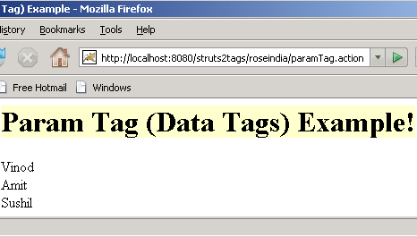

Set Tag (Data Tag) Example
In this section, we are going to describe the Set tag. The set tag is a generic tag that is used to assign a value to a variable in a specified scope. It is useful when you wish to assign a variable to a complex expression and then simply reference that variable each time rather than the complex expression.
Add the following code snippet into the struts.xml file.
struts.xml
<action name="setTag">
<result>/pages/genericTags/setTag.jsp</result>
</action>
Now create a jsp page using <s:set> tag as shown in the setTag.jsp page. The set tag is used to assign a value to a variable in a specified scope. The parameters name and value in the tag <s:set name="technologyName" value="%{'Java'}"/> acts as the name-value pair. Here we set the parameters as name="technologyName" value="Java".
setTag.jsp
<%@ taglib prefix="s" uri="/struts-tags" %>
<html>
<head>
<title>Set Tag (Data Tag) Example!</title>
</head>
<body>
<h1><span style="background-color: #FFFFcc">Set Tag
(Data Tags) Example!</span></h1>
<s:set name="technologyName" value="%{'Java'}"/>
Technology Name: <s:property value="#technologyName"/>
</body>
</html>
Output of the setTag.jsp:
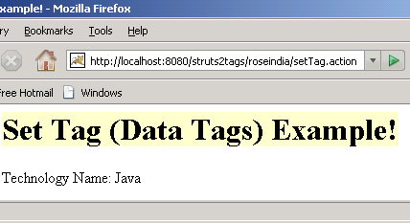

Text Tag (Data Tag) Example
In this section, we are going to describe the text tag. The text tag is a generic tag that is used to render a I18n text message. Follow one of the three steps:
1. Keep the message to be displayed in a resource bundle with the same name as the action that it is associated with ie. create a properties file in the same package as your Java class with the same name as your class, but with .properties extension.
2. If the property file does-not work or the message is not found in the resource bundle, then the body of the tag will be used as default message.
3. If there is no body, then the name of the message will be used.
Add the following code snippet into the struts.xml file.
struts.xml
<action name="textTag" class="net.roseindia.textTag">
<result>/pages/genericTags/textTag.jsp</result>
</action>
Create an action class as shown below:
textTag.java
package net.roseindia;
import com.opensymphony.xwork2.ActionSupport;
public class textTag extends ActionSupport {
public String execute() throws Exception{
return SUCCESS;
}
}
Create a property file in the same package where your Java program file (textTag.java) is saved with the name as package.properties.
package.properties
webname1 = http://www.RoseIndia.net
webname2 = http://www.javajazzup.com
webname3 = http://www.newstrackindia.com
Now create a jsp page to see the working of the text tags.
The first three tags <s:text name="webname1">,<s:text name="webname2"> and <s:text name="webname3"> uses the package.properties file to display the text message.
The next tag <s:text name="empname">Vinod, Amit, Sushil, .......</s:text> uses the body of the tag as a default message.
The last tag <s:text name="empname"></s:text> does not have access to the package.properties files nor does it have a body so it uses name of the message to display.
textTag.jsp
<%@ taglib prefix="s" uri="/struts-tags" %>
<html>
<head>
<title>Text Tag (Data Tag) Example!</title>
</head>
<body>
<h1><span style="background-color: #FFFFcc">Text Tag
(Data Tags) Example!</span></h1>
<s:text name="webname1"></s:text><br>
<s:text name="webname2"></s:text><br>
<s:text name="webname3"></s:text><br>
<s:text name="empname">Vinod, Amit, Sushil, .......</s:text><br>
<s:text name="empname"></s:text>
</body>
</html>
Output of the textTag.jsp:
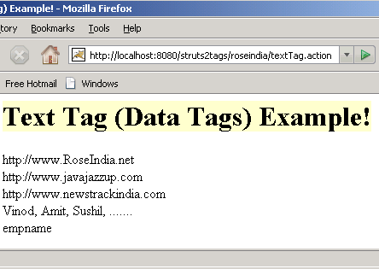

Text Tag (Data Tag) Example
In this section, we are going to describe the text tag. The text tag is a generic tag that is used to render a I18n text message. Follow one of the three steps:
1. Keep the message to be displayed in a resource bundle with the same name as the action that it is associated with ie. create a properties file in the same package as your Java class with the same name as your class, but with .properties extension.
2. If the property file does-not work or the message is not found in the resource bundle, then the body of the tag will be used as default message.
3. If there is no body, then the name of the message will be used.
Add the following code snippet into the struts.xml file.
struts.xml
<action name="textTag" class="net.roseindia.textTag">
<result>/pages/genericTags/textTag.jsp</result>
</action>
Create an action class as shown below:
textTag.java
package net.roseindia;
import com.opensymphony.xwork2.ActionSupport;
public class textTag extends ActionSupport {
public String execute() throws Exception{
return SUCCESS;
}
}
Create a property file in the same package where your Java program

file (textTag.java) is saved with the name as package.properties.
package.properties
webname1 = http://www.RoseIndia.net
webname2 = http://www.javajazzup.com
webname3 = http://www.newstrackindia.com
Now create a jsp page to see the working of the text tags.
The first three tags <s:text name="webname1">,<s:text name="webname2"> and <s:text name="webname3"> uses the package.properties file to display the text message.
The next tag <s:text name="empname">Vinod, Amit, Sushil, .......</s:text> uses the body of the tag as a default message.
The last tag <s:text name="empname"></s:text> does not have access to the package.properties files nor does it have a body so it uses name of the message to display.
textTag.jsp
<%@ taglib prefix="s" uri="/struts-tags" %>
<html>
<head>
<title>Text Tag (Data Tag) Example!</title>
</head>
<body>
<h1><span style="background-color: #FFFFcc">Text Tag
(Data Tags) Example!</span></h1>
<s:text name="webname1"></s:text><br>
<s:text name="webname2"></s:text><br>
<s:text name="webname3"></s:text><br>
<s:text name="empname">Vinod, Amit, Sushil, .......</s:text><br>
<s:text name="empname"></s:text>
</body>
</html>
Output of the textTag.jsp:

Furthur references
(http://www.roseindia.net/struts/struts2/index.shtml)
- Struts 2 Features
It is very extensible as each class of the framework is based on an Interface and all the base classes are given an extra application and even you can add your own.
- Struts 2 History
Apache Struts is an open-source framework that is used for developing Java web application. Originally developed by the programmer and author Craig R. McClanahan this was later taken over by the Apache Software Foundation in 2002.
- Struts 2 Architecture
Struts and webwork has joined together to develop the Struts 2 Framework. Struts 2 Framework is very extensible and elegant for the development of enterprise web application of any size. In this section we are going to explain you the architecture of Struts 2 Framework.
- Why Struts 2
The new version Struts 2.0 is a combination of the Sturts action framework and Webwork. According to the Struts 2.0.1 release announcement, some key features are:
- Struts 1.x Vs Struts 2.x
In the following section, we are going to compare the various features between the two frameworks. Struts 2.x is very simple in comparison to the struts 1.x, few of its excelling features are:
- Downloading and Installing Struts 2
In this section we will download and install the Struts 2.0 on the latest version of Tomcat container. We will first download tomcat and configure it as our development server.
Struts 2 Hello World Application
- Creating the development directory Structure
In this section we will create directory structure of our Struts 2 Hello World application based on Struts 2 framework. Our Struts 2 Hello World application is your first step towards developing applications based on Struts 2 framework.
- Writing Jsp, Java and Configuration files
In this section we will write JSP, Java and required configuration files for our Struts 2 Hello World application. Now in struts 2 struts.xml is used to configure the applications. We will also deploy and test the application.
- Struts 2 xml configuration file
In this section we will introduce you with the struts.xml file. This section explains you how best you can use the struts.xml file for you big projects.
Struts 2 Actions
- Struts 2 Actions Example
When a client request matches the action's name, the framework uses the mapping from struts.xml file to process the request.
- Struts 2 Actions Introduction
When a client request matches the action's name, the framework uses the mapping from struts.xml file to process the request. The mapping to an action is usually generated by a Struts Tag.
- Struts 2 Redirect Action
In this section, you will get familiar with struts 2 Redirect action and learn to use it in the struts 2 application.
Struts 2 Login Application
- Developing Login Application in Struts 2
In this section we are going to develop login application based on Struts 2 Framework. Our current login application does not validate the user against the database.
- Adding Validation to Struts 2 Login Application
In this section we will write the code to validate the login application. After completing this section you will be able to write validations for your Struts 2 projects.
- Running and testing application
In this section we will run the example on Tomcat 6.0 server and check how it works.
- Client Side Validation in Struts 2 Login Application
In this section we will see how to write code that will generate Java Script code for client side validation. In the last section we developed Login-validator.xml configuration file for defining the server side validation.
- Validations using Struts 2 Annotations
In this section we are going to validate our login application using Annotations in Action class. Our current login application does not validate the user against the database.
More Struts Validator Examples
User input validations are an integral part of any web application. With the release of Struts 2, validation are now much easy and robust. Struts 2 support Ajax based and even server side validations.
- Login/Logout With Session
In this section, we are going to develop a login/logout application with session. This application checks the user authentication. Whenever you run, it takes a user id and a password (Both the user id and password is "admin") it displays the welcome page, when both fields are correctly filled.
- Connecting to MySQL Database in Struts 2 (Struts 2 MySQL)
In this section, You will learn to connect the MySQL database with the struts 2 application.
- Rich EditorExample
In this section, you will learn how to create pagination in struts 2.
- Validate TextArea
In this section, you will learn how to validate your text area in struts 2. A text area contains 1 to 250 characters. It cann't support "null" value.
Struts 2 Tags
- Struts Tags
In this section we will introduce you with the tags provided along with Struts 2 framework. It is necessary to understand all the tags provided along with Struts 2 framework.
Struts 2 Tags Examples
- Struts 2 Tags Examples (Generic Tags)
Struts 2 tags tutorials and examples.
- Control Tags-If / Else If / Else
In this section we are going to discuss the various control tags ( The Control Tags are used for flow control such as if, else and iterate.).
- Append Tag (Control Tags) Example
In this section, we are going to describe the append tag. The append tag is a generic tag that is used to merge multiple iterators into one iterator.
- Generator Tag (Control Tags) Example
In this section, we are going to describe the generator tag. The generator tag is a generic tag that is used to generate iterators based on different attributes passed.
- Generator Tag (Control Tags) Using Count Attributes
In this section, we are going to describe the generator tag using the count attributes.
- Generator Tag (Control Tags) Using an Iterator with Id Attributes
In this section, we are going to describe the generator tag using the id attributes.
- Iterator Tag (Control Tags) Example
In this section, we are going to describe the Iterator tag. Iterator tag is used to iterate over a value. An iterable value can be either of: java.util.Collection or java.util.Iterator.
- Merge Tag (Control Tags) Example
In this section, we are going to describe the merge tag. The merge tag is a generic tag that is used to merge iterators. The successive call to the merge iterator causes each merge iterator to have a chance to expose its elements, subsequently next call allows the next iterator to expose its element.
- Subset Tag (Control Tags) Example
In this section, we are going to describe the subset tag. The subset tag is a generic tag that takes an iterator and outputs a subset of it. It delegates to org.apache.struts2.util.SubsetIteratorFilter internally to perform the subset functionality.
- Subset Tag (Control Tags) Example Using Count
In this section, we are going to describe the subset tag using the count parameter. The count parameter indicates the number of entries to be set in the resulting subset iterator.
- Subset Tag (Control Tags) Example Using Start
In this section, we are going to describe the subset tag using the start parameter. The start parameter is of integer type. It indicates the starting index (eg. first entry is 0) of entries in the source (needed to make available as the first entry in the resulting subset iterator).
- Action Tag (Data Tag) Example
In this section, we are going to describe the action tag. The action tag is a generic tag that is used to call actions directly from a JSP page by specifying the action name and an optional namespace.
- Bean Tag (Data Tag) Example
In this section, we are going to describe the Bean Tag. The Bean tag is a generic tag that is used to instantiates a class that confirms to the JavaBeans specification.
- Date Tag (Data Tag) Example
In this section, we are going to describe the Date tag. The date tag allows to format a Date in a quick and easy way. User can specify a custom format(eg. "dd/MM/yyyy hh:mm"), can generate easy readable notations(like "in 2 hours, 14 minutes"), or can just fall back on a predefined format with key 'struts.date.format' in the properties file.
- Include Tag (Data Tag) Example
In this section, we are going to describe the include tag. The include tag is a generic tag that is used to include a servlet's output (result of servlet or a JSP page) to the current page.
- Param Tag (Data Tag) Example
In this section, we are going to describe the param tag. The param tag is a generic tag that is used to parameterize other tags. For example the include tag and bean tag. The parameters can be added with or without a name as a key.
- Set Tag (Data Tag) Example
In this section, we are going to describe the Set tag. The set tag is a generic tag that is used to assign a value to a variable in a specified scope.
- Text Tag (Data Tag) Example
In this section, we are going to describe the text tag. The text tag is a generic tag that is used to render a I18n text message.
- Property Tag (Data Tag) Example
In this section, we are going to describe the property tag. The property tag is a generic tag that is used to get the property of a value, which will default to the top of the stack if none is specified.
- Struts 2 Tags (UI Tags) Examples
Form Tags Examples
- Auto Completer Example
In this section, we are going to describe the autocompleter tag. The autocompleter tag always displays a dropdown list with the options that have at least a partial match with entered text in the textbox. If the user clicks on the dropdown button then all options shown in the dropdown list.
- Checkbox Tag (Form Tag) Example
In this section, we are going to describe the checkbox tag. The checkbox tag is a UI tag that is used to render an HTML input element of type checkbox, populated by the specified property from the ValueStack.
- Checkboxlist Tag (Form Tag) Example
In this section, we are going to describe the checkboxlist tag. The checkboxlist tag is a UI tag that creates a series of checkboxes from a list. Setup is like <s:select /> or <s:radio />, but creates checkbox tags.
- Combobox Tag (Form Tag) Example
In this section, we are going to describe the combobox tag. The combo box is basically an HTML INPUT of type text and HTML SELECT grouped together to give you a combo box functionality.
- Datetimepicker Tag (Form Tag) Example
In this section, we are going to describe the datetimepicker tag. The datetimepicker tag is a UI tag that is used to render a date/time picker in a dropdown container.
- Doubleselect Tag (Form Tag) Example
In this section, we are going to describe the doubleselect tag. The doubleselect tag is a UI tag that renders two HTML select elements with second one changing displayed values depending on selected entry of first one.
- File Tag (Form Tag) Example
In this section, we are going to describe the file tag. The file tag is a UI tag that renders an HTML file input element achieved through browsing.
- Form Tag Example
In this section, we are going to describe the form tag. The form tag is a UI tag that renders HTML an input form.
- Label Tag (Form Tag) Example
In this section, we are going to describe the label tag. The label tag is a UI tag that is used to render an HTML LABEL that allows to output label:name type of combinations that has the same format treatment as the rest of UI controls.
- Optiontransferselect Tag (Form Tag) Example
In this section, we are going to describe the Optiontransferselect tag. The Optiontransferselect tag is a UI tag that creates an option transfer select component.
- Optgroup Tag (Form Tag) Example
In this section, we are going to describe the optgroup tag. The optgroup tag is a UI tag that creates an optgroup component which needs to reside within a select tag <s:select>.
- Password Tag (Form Tag) Example
In this section, we are going to describe the password tag. The password tag is a UI tag that renders an HTML input tag of type password.
- Radio Tag (Form Tag) Example
In this section, we are going to describe the radio tag. The radio tag is a UI tag that renders a radio button input field.
- Reset Tag (Form Tag) Example
In this section, we are going to describe the reset tag. The reset tag is a UI tag that is used with the form tag to provide form resetting.
- Select Tag (Form Tag) Example
In this section, we are going to describe the select tag. The select tag is a UI tag that is used to render an HTML input tag of type select.
- Submit Tag (Form Tag) Example
In this section, we are going to describe the submit tag. The submit tag is a UI tag that is used to render a submit button. The submit tag is used with the form tag to provide asynchronous form submissions.
- Textarea Tag (Form Tag) Example
In this section, we are going to describe the textarea tag. The textarea tag is a UI tag that is used to render an HTML textarea.
- Textfield Tag (Form Tag) Example
In this section, we are going to describe the textfield tag. The textfield tag is a UI tag that is used to render an HTML input field of type text.
- Updownselect Tag (Form Tag) Example
In this section, we are going to describe the updownselect tag. The updownselect tag is a UI tag that creates a select component with buttons to move up and down the elements in the select component.
Non-Form UI Tags
- Actionerror and Actionmessage Tags (Non-Form UI Tags) Example
In this section, we are going to describe the actionerror and actionmessage tags. The actionerror tag is a UI tag that renders action errors (in the jsp pages.) if they exists while the actionmessage tag renders action messages if they exists.
- Fielderror Tag (Non-Form UI Tags) Example
In this section, we are going to describe the fielderror tags. The fielderror tag is a UI tag that renders field errors if they exists.
- TabbedPanel (Ajax Tag) Example
In this section, you will learn about the tabbedPanel tag. This is an Ajax component, where each tab is either a local content or a remote content (refreshed each time when user selects that tab).
- tree and treenode (Ajax Tag) tags Example
In this section, you will learn about the tree and treenode tags. These both work with the Ajax support.
- Div (Ajax Tag) tag Example
In this section, you will learn about the div tag. The div tag is an Ajax component that is used with Ajax that refreshes the contents of a particular section without refreshing the entire page.
Struts 2 Examples
- Struts 2 Date
In this section we will discuss the date processing functionalities available in the Struts 2 Framework.
- Date Format Examples
In this tutorials you will learn about Date Format function in Struts 2. We have provided fully tested example code to illustrate the concepts.
- Struts 2 datepicker Example
In this section we will show you how to develop datetimepicker in struts 2. Struts 2 uses the dojo toolkit for creating date picker.
- Struts 2 Format Examples
In this section you will learn how to format Date and numbers in Struts 2 Framework. Our Struts 2 Format Examples are very easy to grasp and you will learn these concepts in very small time.
- Struts 2 File Upload
In this section you will learn how to write program in Struts 2 to upload the file on the server. In this example we are also providing the code to save the uploaded file in any directory on the server machine.
Struts 2 Resources Examples
- Struts 2 Resources Examples
The struts 2 resources examples
- Static Parameter
In this section, we will develop a simple application to access the static parameters. We will use a JavaBean to set and get the static parameters. Each static parameter has a value.
- Accessing Session Object
In this section, we will develop a simple application to access the framework resources like the session object, session context and the last accessed session time.
- Access Request and Response
In this section, you will learn to develop an application that accesses the request and response object in struts 2 application.
Struts 2 Tools
- Struts 2 Eclipse Plugin
This page contains the examples and the list of plugins that are available for Struts 2 Development using Eclipse IDE.
- Struts 2 IDE
This page contains the list of IDEs available to ease the development of Struts 2 Framework based applications. The IDE for Struts 2 will actually make the development cycle much easier.
- Struts 2 Application
Developing user registration application based on Struts 2 Framework. This Struts 2 Application is a simple user registration application that will help you to learn how to develop real world applications using Struts 2 Framework.
- Struts 2 Ajax
In this section we explain you Ajax based development in Struts 2. Struts 2 provides built-in support for Ajax using Dojo toolkit.
Download Source Code of Struts 2 Tutorial
Download Latest Struts 2

